|  |
| --- |
|  |
| 1. AIFFP Two-Year System-Wide Review   Final Report  20 September 2022 |

Report prepared by:

Penny Davis and Natalia Beghin (Alinea International). Peer reviewed by Jim Adams.

alineainternational.com

Front Cover Image: Honiara Coastline © Alinea International

Contents

Acronyms 4

Executive Summary 5

Introduction 5

Key Findings 5

1. What has the AIFFP achieved to date? 5

2. Is the AIFFP on track to deliver on long-term strategic program outcomes and objectives? 7

3. What challenges have been encountered and what lessons have been learned? 8

Recommendations 8

Introduction 10

About the AIFFP 10

Purpose and Scope of the Review 13

Scope 13

Audiences 13

Key Evaluation Questions 14

Methodology 14

Limitations 15

Ethical considerations 16

Findings 17

Key Evaluation Question 1: What has the AIFFP achieved to date? 17

Key Evaluation Question 2: Is the AIFFP on track on long-term strategic program outcomes and objectives? 38

Key Evaluation Question 3: What Challenges Have Been Encountered and What Lessons Have Been Learned? 45

Conclusion 47

Annexes 49

Annex 1: Evaluation Framework 49

Annex 2: AIFFP Operating Models 54

Annex 3: Documents Reviewed 55

Acronyms

|  |  |
| --- | --- |
| **ADB** | Asian Development Bank |
| **AIFFP** | Australian Infrastructure Financing Facility for the Pacific |
| **APCP** | Australia Pacific Climate Partnership |
| **APS** | Australian Public Service |
| **APTC** | Australia Pacific Technical College |
| **DFAT** | Australian Department of Foreign Affairs and Trade |
| **DFI** | Development Finance Institute |
| **EFA** | Export Finance Australia |
| **ESA** | Environmental and social assessment |
| **ESDD** | Environmental and social due diligence |
| **ESMP** | Environmental and social management plan |
| **GE(D)SI** | Gender equality, (disability) and social inclusion |
| **IESC** | Independent environmental and social consultant |
| **IFB** | Pacific Infrastructure Branch (DFAT) |
| **IMS** | Investment management system |
| **MDBs** | Multilateral development banks |
| **MEL** | Monitoring, evaluation and learning |
| **NAIF** | Northern Australia Infrastructure Fund |
| **ODA** | Overseas Development Assistance |
| **OTP** | Office of the Pacific (DFAT) |
| **PICs** | Pacific Islands Countries |
| **SOPs** | Standard operating procedures |
| **UCTF** | Undersea Cables Task Force |
| **WBG** | World Bank Group |

Executive Summary

# Introduction

The Australian Infrastructure Financing Facility for the Pacific (AIFFP) was declared “open for business” on 1 July 2019. Established to respond to the Pacific’s infrastructure deficit and to support Australia’s strategic interests in the region, the AIFFP provides infrastructure loans and grants to assist in stabilising Pacific economies and catalysing economic activity. It is a core component of the Australian Government’s *Pacific Step-up* strategy. Export Finance Australia (EFA) acts as the lender of record and also provides ‘back-office’ support across a range of areas.

The AIFFP’s three strategic objectives are:

* + Pacific countries have increased access to capital to support quality, resilient and inclusive economic infrastructure;
  + Australia delivers infrastructure financing that meets the development needs of Pacific countries; and
  + Australia is a partner of choice for financing infrastructure in the Pacific.

This two-year system-wide Review was commissioned by the AIFFP. It examines the AIFFP’s establishment phase up to end-2021, with the majority of data collected in late 2021. The Review considers whether the AIFFP is well positioned to achieve its long-term objectives and also identifies lessons for improvement.

Data collection methods included a document review, interviews with key stakeholders (including DFAT staff and Pacific partners), and a comparison of the AIFFP’s performance with other similar financiers. The Review’s audiences include Australian Government stakeholders and AIFFP senior management, who can use the Review to understand the AIFFP’s progress and identify priorities for improvement.

# Key Findings

The Review makes 20 findings and 10 recommendations. These are summarised under the Review’s three Key Evaluation Questions.

## 1. What has the AIFFP achieved to date?

Q1A. To what extent is the AIFFP office operating effectively and efficiently to source, select and implement investments?

The Review finds that the AIFFP office is operating effectively and efficiently to source, select and execute investments. The AIFFP architecture – covering its operating model and governance arrangements – has enabled the AIFFP to make good progress, including finalising 10 capital works investments since 2019 (Finding 1). The AIFFP has also made considerable and impressive progress to develop high quality systems to meet its needs. These systems include its Policy Handbook and Standard Operating Procedures, and its due diligence, risk management, monitoring, evaluation and learning, and procurement systems (Finding 3).

To increase the effectiveness and efficiency of AIFFP operations in the future, the Review finds that:

* + The AIFFP could explore the Australian Government’s appetite for operating models which may increase the AIFFP’s efficiency (Finding 2). This is because the current hybrid model, in which the requirements of both the AIFFP and EFA must be met, creates complexity in the AIFFP’s operations;
  + Finalising its Investment Management System (IMS) should be an immediate priority for the AIFFP, given that the absence of an IMS has created inefficiencies for the AIFFP (Finding 4);
  + The AIFFP should consider how it can shape demand from partners for investments in high-priority sectors and countries (Finding 5). This will help ensure the AIFFP is able to develop a portfolio of investments which matches the AIFFP’s desired mix of objectives and risk profile; and
  + The AIFFP should consider how appropriate policy and regulatory environments, and provisions for longer-term maintenance, can be supported in partner countries (Finding 6). This is because the AIFFP’s long-term objectives will be achieved only if its infrastructure investments are supported by appropriate policy and regulatory frameworks, capacity, and maintenance programs. DFAT bilateral country programs and other funders may be well placed to work with the AIFFP in these areas.

The Review also finds that AIFFP staff are high quality and have built strong relationships with Pacific partners (Finding 7). At the same time, the Review finds that additional staff resources to support AIFFP operations should be sought (Finding 8). AIFFP staff resources are significantly lower than those of other similar infrastructure financiers, and its current staffing level poses a risk to the AIFFP achieving its strategic objectives. For any additional staff resources that are acquired, the AIFFP should consider prioritising these to implementation oversight and safeguards (Finding 8). This will ensure the AIFFP can continue to make progress towards its strategic objectives and manage its risks appropriately. The AIFFP should experiment with the placement of in-country staff to determine if this should also be a future staffing priority (Finding 9).

### Q1B: To what extent has the AIFFP developed an appropriate pipeline of investments, within its overall investment envelope, with good economic and inclusive development potential?

The Review finds that the AIFFP has established an appropriate pipeline of investments with good economic and inclusive development potential. The AIFFP’s timelines, from its establishment to the announcement of initial loans, compare favourably with similar entities, such as the Northern Australia Infrastructure Facility (Finding 10). Further, the AIFFP’s policies and systems for economic and social benefits, climate resilience, and environmental and social safeguards are high quality and are likely to contribute to investments achieving benefits in these areas (Finding 11).

For the future:

* + The AIFFP should consider mechanisms to improve communication and coordination with relevant programs and partners, such as the Australia Pacific Technical College (APTC), the Australia Pacific Climate Partnership (APCP) and other funders (Finding 12). This would enable these partners to better support the AIFFP;
  + The AIFFP should consider options to increase disability inclusion in its systems and policies (Finding 12). Although individual investments have specific measures related to disability inclusion, higher level policies and guidance to support disability inclusion could be developed further; and
  + The AIFFP and EFA should explore an agreement to establish an environmental and social due diligence process that includes a level of reliance on the AIFFP’s safeguards systems, though full reliance may never be possible given EFAs role as lender of record (Finding 13). Currently, the AIFFP and EFA have similar, though not identical, safeguard standards which must both be met. Complexity and inefficiency could be reduced by establishing a system that gives the AIFFP greater autonomy around decision-making in safeguards while also acknowledging EFA’s role as lender of record.

### Q1C: How does the AIFFP’s progress compare to that of other infrastructure financiers in the region?

The Review finds that the AIFFP has made good progress since its establishment in 2019 when compared to that of other infrastructure financiers in the region (Finding 14). For example:

* + In 2021, the AIFFP was the second-largest infrastructure financier in the Pacific by financing value and number of projects; and
  + When examining indicators of inclusiveness – such as the availability of policies related to gender equality and social inclusion (GESI), climate resilience, and social safeguards – the AIFFP performs above average compared to other financiers.

## 2. Is the AIFFP on track to deliver on long-term strategic program outcomes and objectives?

### Q2A: To what extent will AIFFP investments support quality, resilient and inclusive infrastructure in the Pacific?

The Review finds that AIFFP investments are likely to support quality, resilient and inclusive infrastructure in the Pacific. A key contributing factor is that the AIFFP has an appropriate pipeline of investments in place (Q1B discussion above).

In addition, the Review finds that the AIFFP has built strong relationships with a number of Pacific partners (Finding 15). Both sovereign and private-sector Pacific partners receiving financing from the AIFFP reflected very positively on the AIFFP, highlighting that it has worked effectively with Pacific partners, has taken culturally sensitive approaches, is focused on action, and has been responsive to partners’ infrastructure financing needs.

### Q2B: Is the AIFFP positioning itself as a partner of choice for financing infrastructure, including shaping of demand for quality infrastructure, in the Pacific region?

The Review finds that the AIFFP has positioned itself as a partner of choice in the Pacific. The AIFFP has established an appropriate pipeline of investments, and Pacific partners expressed positive sentiment about the AIFFP and its approaches. Further, a number of Pacific partners express a clear preference for working with the AIFFP, highlighting that it is currently the highest-performing group that they work with (Finding 17).

To continue its positive trajectory in this area:

* + The AIFFP should consider options for improving the competitiveness of its loans, with a particular focus on the headline interest rate and on increasing the ease of borrowing for partners (Finding 16). AIFFP loans have needed to cover EFA’s cost of funding (from the market) and administering the loan, meaning that the AIFFP struggles to be competitive with other lenders who are able to offer highly concessional loans independent of funding costs. This challenge could be addressed if the AIFFP was able to offer below costs of funds loans; and
  + The AIFFP should consider how it can set clearer expectations for Pacific partners on the likely timeframes for investment approvals (Finding 18). This could help address Pacific partners’ concerns that the timelines for investment approval are slow and that the multiple approval steps required are challenging to understand.

### Q2C: To what extent are AIFFP investments responding to the infrastructure development needs of Pacific Island countries?

The Review finds that the AIFFP is responding appropriately to the infrastructure development needs of Pacific Island countries. The AIFFP has made additional financing available in the Pacific, and Pacific partners view the AIFFP positively and perceive that it is responding to their needs.

## 3. What challenges have been encountered and what lessons have been learned?

### Q3A: How have significant environmental changes since the AIFFP design in 2019 (specifically COVID-19) impacted on AIFFP delivery – or alternatively, provided opportunity for experimentation?

The Review finds that the AIFFP has responded well to the COVID-19 pandemic (Finding 19). The AIFFP updated its policies to ensure its investments could assist Pacific partners to respond to COVID-19 and stabilise their economies. The AIFFP also carefully considers COVID-19 responses and impacts as part of its investment approval process. In addition, the AIFFP has adapted appropriately to the challenges of operating during a pandemic, with Pacific partners sharing that the AIFFP continued to work well with partners virtually.

### Q3B: What are the priorities for change and strengthening based on lessons and experience to date?

The Review finds that the AIFFP is continually seeking to identify lessons and improve for the future (Finding 20). It has a robust monitoring, evaluation and learning system; it conducts regular internal information-sharing sessions and performance discussions; and it is actively considering how it can make accessible case studies on topics of relevance across the AIFFP.

# Recommendations

Some of the findings discussed above relate to areas in which the AIFFP should consider action in order to improve or to manage risks. These are summarised below and constitute the recommendations from this Review.

The first set of recommendations are the highest-priority recommendations from this Review. They are areas in which, according to the Review team’s, action should be prioritised to enable the AIFFP to achieve its strategic objectives in the long term.

|  |  |
| --- | --- |
| **Recommendation #** | **Finding / Recommendation** |
| Recommendation 1 | Finding 8: Additional staff resources to support AIFFP operations should be sought. For any additional staff resources required, consideration should be given to prioritising these to implementation oversight and safeguards. |
| Recommendation 2 | Finding 9: The AIFFP should experiment with the placement of staff in-country to determine if this should become a priority. |
| Recommendation 3 | Finding 16: The AIFFP should propose to the Australian Government options to improve the competitiveness of the AIFFP’s loans, with a particular focus on the headline interest rate and the ease of borrowing for partners. |
| Recommendation 4 | Finding 2: For the longer term, the AIFFP could explore the Australian Government’s appetite for operating models which may increase the AIFFP’s efficiency. |

Other recommendations from the Review are outlined below. These focus on improving the AIFFP’s effectiveness and efficiency, its relationship with partners, and its operations.

|  |  |
| --- | --- |
| **Recommendation #** | **Finding / Recommendation** |
| Recommendation 5 | Finding 6: The AIFFP should consider how appropriate policy and regulatory environments, and provisions for longer-term maintenance, can be supported in partner countries to ensure the AIFFP can achieve its long-term objectives. |
| Recommendation 6 | Finding 13: To increase efficiency and attractiveness to partners, the AIFFP and EFA should explore an agreement to establish an environmental and social due diligence process that includes a level of reliance on the AIFFP’s safeguards systems. However, full reliance may never be possible given EFA’s role as lender of record. |
| Recommendation 7 | Finding 5: The AIFFP should consider how it can share demand from partners for investments in high-priority sectors and countries. |
| Recommendation 8 | Finding 18: The AIFFP should consider how it can set clearer expectations with Pacific partners on the likely timeframes for investment approval. |
| Recommendation 9 | Finding 12: The AIFFP should consider mechanisms to improve communication and coordination with relevant programs/partners and options for increasing disability inclusion guidance in its systems and policies. |
| Recommendation 10 | Finding 4: The AIFFP should finalise the IMS as an immediate priority. |

Introduction

# About the AIFFP

Quality infrastructure is a key driver of sustainable economic growth. It stimulates trade and investment, generates employment, and can increase productivity. It also contributes significantly to the welfare of citizens by improving the efficiency and reliability of transport, telecommunications, and the supply of water and energy. Notwithstanding these benefits, there is a global infrastructure financing gap, the value of which significantly exceeds the amount of domestic revenue, foreign loans, and official development assistance (ODA) available for infrastructure development. This gap is most acute in the Pacific, where the Asian Development Bank (ADB) estimates over USD30 billion in investment is required to meet infrastructure financing needs out to 2030.[1]

Announced by then Prime Minister Morrison on 8 November 2018 and declared “open for business” by then Foreign Affairs Minister Payne on 1 July 2019, the Australian Infrastructure Financing Facility for the Pacific (AIFFP) is a core component of the Australian Government’s *Pacific Step-up* strategy. Established to respond to the Pacific’s infrastructure deficit and to support Australia’s strategic interests in the region, the AIFFP’s original funding envelope was AUD2 billion, covering AUD1.5 billion in loans and AUD500 million in grants. In the 2022–23 budget, the Australian Government announced an increase in the AIFFP’s lending cap from AUD1.5 billion to AUD3 billion. As a result, the AIFFP is now a AUD3.5 billion initiative.

The AIFFP prioritises finance for infrastructure to assist in stabilising Pacific economies and catalysing economic activity. As outlined in its Monitoring, Evaluation and Learning Plan, the AIFFP’s three strategic objectives are:

* + Pacific countries have increased access to capital to support quality, resilient, and inclusive economic infrastructure;
  + Australia delivers infrastructure financing that meets the development needs of Pacific countries; and
  + Australia is a partner of choice for financing infrastructure in the Pacific.

In servicing these objectives, the AIFFP works closely with governments and other development partners in the region to help determine infrastructure priorities. It gives precedence to investments that are aligned with Pacific partners’ existing infrastructure planning processes. Moreover, the AIFFP is committed to developing quality infrastructure which accords with agreed international principles, satisfies robust social and environmental safeguards, and maximises development impact, such as by encouraging the participation of Pacific workers. The AIFFP does not offer loans to sovereign governments or to state-owned enterprises that would endanger overall debt sustainability. These approaches ensure that the AIFFP operates within the Australian Government’s development performance framework and supports the objectives of *Partnerships for Recovery – Australia’s COVID-19 Development Response*.

The AIFFP is housed within the Pacific Strategy Division of the Office of the Pacific (OTP), inside the Australian Department of Foreign Affairs and Trade (DFAT). OTP was established in 2018 as part of a series of economic, security, and people-to-people initiatives undertaken by the Australian Government to boost Australia’s engagement with Pacific Island countries and Timor-Leste. The AIFFP is comprised of DFAT officials, contracted specialists and secondees from other Commonwealth agencies, and is supported by staff from across DFAT, including staff at overseas posts. Export Finance Australia (EFA) is the lender of record for AIFFP loans and also provides “back-office” loan administration, disbursement, and associated functions on behalf of the AIFFP. EFA’s legislative and operational capabilities therefore enable the AIFFP to provide loans.

Table 1 over page contains a list of AIFFP investments from March 2022 which informed the analysis in this Review Report.

Table 1: List of AIFFP investments used to inform this Review

|  |  |  |  |  |
| --- | --- | --- | --- | --- |
| **AIFFP Investment** | **Debtor/Recipient** | **Transaction Value  (AUD millions)** | **Sector** | **Project Type** |
| Airports Fiji Ltd | Fiji | 67.8 | Aviation/Maritime/Transport | Capital Works |
| Connect PNG Roads | Papua New Guinea | 72.2 | Aviation/Maritime/Transport | Capital Works |
| East Micronesia Cable | Federated States of Micronesia/Kiribati/Nauru | 60 | Telecommunications/ICT | Capital Works |
| Nauru Transport Infrastructure Rehabilitation | Nauru | 30 | Aviation/Maritime/Transport | Capital Works |
| Palau ICT Cable | Palau | 17.7 | Telecommunications/ICT | Capital Works |
| Palau Solar Pacific | Palau | 29.3 | Energy/Utilities | Capital Works |
| PNG Ports Development | Papua New Guinea | 580.4 | Aviation/Maritime/Transport | Capital Works |
| PNG Power Sector Development Project | Papua New Guinea | 85.8 | Energy/Utilities | Capital Works |
| Tina River Hydropower Transmission System | Solomon Islands | 30.5 | Energy/Utilities | Capital Works |
| Tonga Parliament House | Tonga | 13 | Urban Infrastructure | Capital Works |
| Fiji Nadi Flood Alleviation – Catchment Management | Fiji | 5 | Other | Preparation |
| PNG Electrification Preparation | Papua New Guinea | 3.5 | Energy/Utilities | Preparation |
| PNG Ports Development – Preparation | Papua New Guinea | 8 | Aviation/Maritime/Transport | Preparation |
| PNG Ports Supervision | Papua New Guinea | 13.3 | Aviation/Maritime/Transport | Preparation |
| PNG Transport Preparation | Papua New Guinea | 8 | Aviation/Maritime/Transport | Preparation |
| Timor-Leste Cable Implementation Support | Timor-Leste | 7 | Telecommunications/ICT | Preparation |
| Timor-Leste Cable Front-end Engineering Design (FEED) | Timor-Leste | 2 | Telecommunications/ICT | Preparation |

# Purpose and Scope of the Review

As a condition of the AIFFP design and origination process, DFAT undertook to conduct a system-wide review (the Review) of the AIFFP two years after its establishment. In delivering against that commitment, this Review provides:

* + An assessment of the AIFFP’s progress towards its strategic objectives; and
  + Lessons on what has and has not worked well.

## Scope

This Review covers the AIFFP’s establishment phase and considers whether the AIFFP is well positioned to achieve its long-term objectives as it transitions its core business towards investment execution and implementation activities. The Review examines the AIFFP’s:

* + Progress and performance since establishment in July 2019;
  + Governance, policies, institutional systems, processes, risk management and capabilities; and
  + Project pipeline development and processes.

The Review also considers:

* + Contextual factors which may have affected the AIFFP’s establishment phase; and
  + The effects of, and the AIFFP’s response to, the COVID-19 pandemic.

The Review excludes consideration of:

* + Contextual factors that are highly sensitive and/or classified;
  + Alternative models for the AIFFP; and
  + Implementation of AIFFP investments.

The Review primarily covers the period of July 2019 to December 2021, with the bulk of data collection and analysis taking place in late 2021. AIFFP investments which were finalised or nearing finalisation in early 2022 are also included in the Review’s analysis. This reflects the fact that most of the work related to these investments was completed during the Review’s 2019–2021 timeframe.

This Review builds on an internal AIFFP systems review conducted by Deloitte in 2020. The Deloitte review aimed to identify improvements to the AIFFP’s human capabilities, systems and processes that would result in a more efficient and effective delivery of the AIFFP’s objectives. This current Review re-examines some of these capabilities, systems and processes, while also considering broader topics such as governance, project pipeline development, and early progress towards the AIFFP’s objectives.

## Audiences

The primary audience for this Review is Australian Government stakeholders, including parliamentarians, their staff, and government departments. These groups can use the report to understand the AIFFP’s progress and achievements to date.

The secondary audience for this Review is the AIFFP management team. This group can use the Review’s findings to identify priorities for improvement in the AIFFP.

## Key Evaluation Questions

The Review has been guided by the following Key Evaluation Questions:

1. What has the AIFFP achieved to date?

a. To what extent is the AIFFP operating effectively and efficiently to source, select and implement investments?

b. To what extent has AIFFP developed an appropriate pipeline of investments, within its overall investment envelope, with good economic and inclusive development potential?

c. How does the AIFFP’s progress compare to that of other infrastructure financiers in the region?

**2. Is the AIFFP on track to deliver on long-term strategic program outcomes and objectives?**

a. To what extent will AIFFP investments support quality, resilient and inclusive infrastructure in the Pacific region?

b. Is the AIFFP positioning Australia as a partner of choice for financing infrastructure, including shaping of demand for quality infrastructure, in the Pacific region?

c. To what extent are AIFFP investments responding to the infrastructure development needs of Pacific Island countries?

**3. What challenges have been encountered and what lessons have been learned?**

a. How have significant environmental changes since the AIFFP design in 2019 (specifically COVID-19) impacted on AIFFP delivery – or alternatively, provided opportunity for experimentation?

b. What are the priorities for change and strengthening based on lessons and experience to date?

## Methodology

### Factors for Exploration

The Review team identified factors for exploration to underpin Key Evaluation Questions 1 and 2. These factors were informed by preliminary desk-based research and select stakeholder consultation undertaken by the Review team, and they were subsequently agreed to by the AIFFP. Each factor was identified as an indicator that would provide robust guidance and evidence on elements the AIFFP should have in place in order to underpin strong performance and progress into the future. In particular, the factors for exploration were developed to:

* + Define the scope of what the Review examined. The factors outline the specific topics and themes about which the Review collected evidence; and
  + Provide guidance on what quality, resilient, and inclusive infrastructure looks like for the AIFFP. The Review team made judgements on the AIFFP’s performance using these factors as a guide.

Note that certain factors for exploration that were identified during the inception phase of the Review have been excluded from this report and its attendant analysis. These exclusions were undertaken either because the factor for exploration was found to be extraneous in the course of research, or because too little data was retrievable to inform robust analysis. Where a factor for exploration has been excluded from this Review Report, this is noted in the report.

The factors for exploration for each Key Evaluation Question are quoted throughout the body of this document and are summarised in Annex 1. No factors for exploration were developed for Key Evaluation Question 3 as an open-ended, exploratory approach was taken for this question.

### Data collection and analysis

The AIFFP team provided a range of documents to be used as data sources in this Review. These included internal AIFFP policies, standard operating procedures, guidelines, and reviews; AIFFP’s project pipeline; and project documents submitted to the AIFFP Board. The Review team reviewed and coded AIFFP documentation using the qualitative data analysis software NVivo. This review process identified key themes arising from the documentation and mapped each qualitative data element against the Key Evaluation Questions and factors for exploration. Documents reviewed are listed in Annex 3.

The Review team interviewed 64 stakeholders between October 2021 and December 2021. Stakeholders were nominated by the AIFFP with guidance from DFAT posts and desks, and comprised representatives of Australian Government departments and agencies, partner governments, multilateral development banks, and AIFFP project partners. Common semi-structured interview guides were prepared to ensure consistency across all consultations. These guides were adapted throughout the consultation process to build on learnings from prior interviews and address new themes for exploration as they arose. Interview notes were then coded in the same manner as AIFFP documentation, enabling triangulation of findings and evidence.

To understand the infrastructure financing landscape in the Pacific, the Review Team examined publicly available project-level investment data to support analysis of infrastructure-related financial flows, and particularly lending, in the Pacific between 2015 and 2021 (and 2022, including pipeline projects, for the AIFFP[2]). The Review team also collected publicly available data on the performance of other infrastructure financiers and compared this data to performance data provided by the AIFFP. From this analysis, two statistical models were developed. The first model, termed the Base Landscape Analysis, considers infrastructure financing flows at the project level. The second, termed the Benchmarking model, aggregates this project data at the financier level to inform comparisons of the AIFFP’s performance to other facilities which provided loans between 2019 and 2021. Both of these models have been designed to act as ongoing internal resources for DFAT and have been built to absorb additional data from both public and classified sources in future.

### Validation

A validation process provided the opportunity to ‘ground-truth’ key findings, identify gaps, and clarify any areas of uncertainty for the Review. The draft Review report was peer reviewed by Jim Adams, a former Vice-President of the World Bank. A draft Review report was provided to the AIFFP for comment in April 2022. The Review team and the AIFFP also held a validation workshop on 9 May 2022 to discuss findings and refine recommendations.

## Limitations

Due to COVID-19 restrictions and risks, most stakeholder interviews were conducted remotely via WebEx. This limited opportunities for the Review team to build rapport with participants and interpret their non-verbal communication. Additionally, several interviewees nominated by DFAT either declined the opportunity to engage with the Review process or were unresponsive to multiple requests from the Review team. Unfortunately, this trend was most prevalent within the Pacific, meaning that the Review includes fewer views from Pacific country stakeholders than initially intended. The Review team also anticipates that some interviewees, including Pacific-based participants, may have found it challenging to provide frank views, given their interests in maintaining a strong relationship with the AIFFP.

To mitigate these limitations, all interviewees were assured that any reporting of subjective views would be de-identified (see below). Review team members were also matched with interview participants with whom they shared the most context. For instance, former civil servants spoke with Australian Public Service staff, while the Review team’s Fijian-national member interviewed Pacific partners.

## Ethical considerations

This Review was planned, conducted, and produced in accordance with the DFAT Monitoring and Evaluation Standards (2017) and the DFAT Ethical Research and Evaluation Guidance (2021). Appropriate consideration was afforded to:

* + **Informed consent:** Prior to taking part in an interview, all interviewees were provided with an overview of why they were being consulted, how the information they provided would be used and stored, and confirmation that their participation was voluntary and could be withdrawn at any time, including after the interview was complete. Where relevant, the Review team also confirmed their security clearance status with the participants. No consultation was commenced before verbal consent from participants was obtained. No participant elected to withdraw from consultations.
  + **Privacy and confidentiality:** To promote participants’ privacy and confidentiality, all interview notes were saved and stored on Alinea servers which were not accessible to DFAT staff. This report ensures the views and identities of individual interviewees are protected and cannot be inferred. Where position titles, direct quotes, or other potentially distinguishing personal information has been presented within this report, participants’ consent has been explicitly obtained.

Findings

# Key Evaluation Question 1: What has the AIFFP achieved to date?

This section discusses what the AIFFP has achieved to date. It focuses on three sub-questions and the factors for exploration which were defined under these sub-questions.

Q1a: To what extent is the AIFFP office operating effectively and efficiently to source, select and implement investments?

### Summary of key findings

The Review finds that the AIFFP office is operating effectively and efficiently to source, select and execute investments. The AIFFP has established a strong policy framework and standard operating procedures as well as robust systems in due diligence, risk management, MEL and procurement. A notable gap is an Investment Management System (IMS), which is under development. The AIFFP’s operating model and governance have enabled it to develop and approve a number of investments across the Pacific, and its staff are high quality and have built strong relationships with Pacific partners.

Factors for exploration

At the Review’s inception stage, the following factors for exploration for this sub-question were identified. Each of these factors is discussed in more detail below.

|  |  |
| --- | --- |
| **Sub-question** | **Factors** |
| a. To what extent is the AIFFP office operating *effectively* and *efficiently* to source, select and implement investments? | If the AIFFP office is operating effectively and efficiently, we expect to see:   * **AIFFP architecture** – specifically the operating model and governance – is fit-for-purpose and facilitating the achievement of the AIFFP’s strategic objectives[3] * **AIFFP systems** – specifically risk management, cross-team planning, and MEL – are fit-for-purpose and facilitating the achievement of the AIFFP’s strategic objectives * **AIFFP staffing** – specifically staff resources, team composition, and team structure – are fit-for-purpose and facilitating the achievement of the AIFFP’s strategic objectives * An appropriate pipeline of investments is in place as addressed under Q1B |

AIFFP architecture: Background

The AIFFP governance and operating model is detailed and comprehensive, which reflects the complexity of infrastructure financing in the Pacific. The AIFFP team, together with Posts and EFA, identify and develop new infrastructure loans with sovereign and private sector partners(hereafter ‘partners’). This process includes multiple steps, such as conducting risk assessments, partner due diligence, and environmental and social safeguard assessments; developing approaches for project procurement, monitoring and evaluation, gender equality and social inclusion, and climate resilience; and encouraging local contractors to get involved. EFA’s role in this process differs depending on the type of transaction and is larger for non-sovereign deals which require more complex loan structuring, documentation and credit assessments. The process also includes Australia’s Infrastructure and Project Financing Agency, which provides advice on the completeness and robustness of the commercial, financial and risk analysis undertaken by the AIFFP.

Following this initial work, investment proposals are submitted to the AIFFP Board for consideration and endorsement. The Board is chaired by DFAT and includes officials from DFAT, Department of Prime Minister and Cabinet, Department of Finance, and Treasury as well as independent external appointees with private-sector lending expertise. Following AIFFP Board endorsement, investment proposals are submitted to the Minister for Foreign Affairs for approval and then to the EFA Board for consideration.

Although the AIFFP/DFAT originate the infrastructure loans, DFAT is not able to issue loans. This role is fulfilled by EFA, which can issue loans from the National Interest Account (NIA) and provide guarantees on behalf of the AIFFP**.** As EFA is the ‘lender of record’, proposed loans must meet EFA’s requirements (for example, in relation to due diligence and safeguards) and be referred to the Minister for Trade and Tourism by the EFA Board. This creates a hybrid operating model in which both the AIFFP and EFA have requirements that must be met with respect to the provision of AIFFP loans.

Once the EFA Board has referred a loan to the Trade Minister, the Trade Minister and the Minister for Foreign Affairs refer the proposal to the Government for approval. If the Government agrees to EFA providing the loan on behalf of the AIFFP, the Trade Minister then directs EFA to issue the loan.

AIFFP architecture: Findings

To date, the AIFFP architecture has served the AIFFP well. As of early 2022, this architecture has enabled the AIFFP to finalise a significant number of investments since it became ‘open for business’ in 2019. These investments include 10 capital works investments. The AIFFP has operated relatively quickly when compared to similar financiers such as the Northern Australia Infrastructure Facility (NAIF) (this is discussed in more detail under Q1B).

As outlined above, a key element of the AIFFP architecture is that EFA is used as the ‘lender of record’. Using EFA in this role enabled the AIFFP to become operational quickly because the AIFFP was able to draw on EFA’s loan systems and processes rather than developing its own. Interviews with the AIFFP and EFA staff demonstrated that the two organisations have built strong relationships and have an open, solutions-orientated approach to communication and problem solving.

Finding 1: To date, the AIFFP architecture has enabled the AIFFP to make good progress.

At the same time, the Review found that the AIFFP architecture – particularly the hybrid AIFFP-EFA operating model – is not as efficient as it could be. The AIFFP and EFA staff have strong relationships, but the hybrid model creates structural challenges which are difficult to overcome through strong relationships alone.

In particular, EFA has been directed by the Government to normally operate the National Interest Account on a commercial basis. It therefore uses loan documentation which is commercial in nature. To date, the AIFFP has been required by government policy to ensure its loans cover EFA costs in funding and administering the loan. This requirement has protected the profitability of the National Interest Account.

The way in which EFA has been instructed to operate can conflict with the AIFFP’s mandate. The AIFFP seeks to offer highly competitive loans to partners with simple loan documentation. This is to ensure that Pacific partners have access to finance; that the AIFFP is not contributing to unsustainable debt burdens;[4] and that the AIFFP is considered a ‘partner of choice’ in the Pacific. Given the nature of the AIFFP’s competitors, this means that AIFFP sovereign loans likely need to be offered with interest rates and fees that are as competitive as possible, with many alternative financiers offering concessional loans below their cost of funds (which the AIFFP cannot do).

While loan pricing challenges are a broader question for the Australian Government, a key challenge remains that EFA is required to operate the National Interest Account on a commercial basis. To enable EFA to offer competitive loans, for some Pacific partners the AIFFP offers grants alongside EFA-issued loans to ensure that a more concessional funding package is provided. The AIFFP also uses a range of other measures to make its loan/grant packages more attractive; these are discussed further under Q2B.

This loan/grant approach for sovereign loans, while satisfying the requirements of both EFA and the AIFFP, is cumbersome and creates complexity in the AIFFP’s operations. Interviewees highlighted that this approach leads to significant and time-consuming back-and-forth between the two organisations in order to agree on and finalise loan documents, and to ensure these loan documents are synchronised with separate grant documents. It will also create inefficiencies for partners in the future, who will be required to request funds from loans and grants separately and adhere to two separate agreements. However, there are benefits in the additional transparency it provides in regard to the true cost to the Commonwealth in the provision of this financing.

The Review also finds that the hybrid AIFFP operating model is unusual – and more complex – when compared to the operating models of other infrastructure financiers. Multilateral development banks such as the World Bank and the Asian Development Bank offer concessional loans, with terms covered in a single set of loan documentation – an approach which is simple for their partners. Australia-focused financiers, such as NAIF, have used EFA for their back-office loan functions but are not able to offer grants alongside NAIF-issued loans, and do not rely on EFA as lender of record, or assistance in credit assessment and loan structuring.

The complexity created by the AIFFP’s operating model suggests that the AIFFP should start examining alternative operating models – and their respective opportunities and challenges – with a view to identifying an operating model which may increase its efficiency. Several ideas for alternative operating models were shared with the Review team and are provided in Annex 2.

The AIFFP should also consider short-term options to improve its efficiency and competitiveness, such as making a concessional loan product available to partners. This is discussed in more detail under Q2B.

Finding 2: For the longer term, the AIFFP could explore the Australian Government’s appetite for operating models which may increase the AIFFP’s efficiency.

AIFFP systems: Background

This section discusses a number of AIFFP systems. It describes these systems and contains the Review’s assessment of the extent to which they are enabling the AIFFP to operate effectively and efficiently.

As outlined in the ‘factors for exploration’ above, at the Review’s inception, three systems were identified as high priority to examine: risk management; cross-team planning; and monitoring, evaluation and learning (MEL). During the Review, other systems – specifically, the AIFFP’s Policy Handbook and Standard Operating Procedures (SOPs), the AIFFP’s procurement framework and investment management system – were identified as high priority and are discussed below. At the same time, it became apparent that cross-team planning was a lower priority than originally anticipated and, as a result, it is not discussed further in this report. Finally, note that systems for safeguards, gender equality, disability and social inclusion (GEDSI) and climate resilience are discussed under Q1B below.

It is important to note that although the AIFFP’s main focus is the provision of infrastructure loans, it sits within an organisation where the vast majority of overseas development assistance is provided through grants. As a result, the AIFFP has been required to adapt DFAT guidance, frameworks and systems to meet the specific requirements for infrastructure finance. This has not always been straightforward. Existing DFAT systems – such as its financial management system – are not easy to adjust, while obtaining internal DFAT support to develop more relevant systems has not been simple.

In this context, the AIFFP has made considerable and impressive progress in its establishment phase to implement a number of high-quality systems that meet its needs, as discussed further below. This Review’s findings are supported by the internal AIFFP systems review conducted by Deloitte in 2020. It concluded that the AIFFP was well positioned to meet its mandate in the short-medium term, and that it had quickly established a solid operational footing. Further evidence of the AIFFP’s success comes from the AIFFP’s response to the Deloitte review. AIFFP agreed to the review’s 32 recommendations to improve its systems and processes, and has self-assessed that 28 are completed, 3 are ‘on track’, and 1 is overdue.

Note that the implementation of many of the systems discussed below has been limited to date because of the early stage of many AIFFP investments. Thus, although this Review provides an assessment of the systems’ design and documentation, it is not always able to comment on how they are implemented in practice.

AIFFP systems: Findings

**Policy Handbook and Standard Operating Procedures**

The AIFFP has two key internal documents which summarise its policies and procedures and ensure that the AIFFP adheres to its design. These are:

* + The AIFFP Policy Handbook, which sets out, at a high level, the AIFFP’s key policies for its staff; and
  + The AIFFP SOPs, which provide guidance to AIFFP staff from project origination to approval. The Review team understand a second chapter focused on project implementation is under development.

The Review team finds that these overarching documents are high quality and likely to support the AIFFP to achieve its strategic objectives[5]. In particular, the documents are clear, easy to use, and provide further contacts and links to additional guidance and templates on specific topics. They also outline how AIFFP staff should interact with other sections in DFAT on particular topics (for example, the safeguards section, child protection specialists, and climate change experts). In a large organisation such as DFAT, clarity on such engagement is key to efficient interactions that support the AIFFP’s needs.

For the future, the SOPs chapter on implementation should be progressed as a matter of priority given many AIFFP investments are moving into the implementation phase. Regular updates of the Policy Handbook and SOPs will also be required as the AIFFP continues to learn and adapt its approaches; updates should be scheduled accordingly.

**Due diligence**

The AIFFP’s policy on due diligence outlines that:

* + A risk-based approach has been adopted, where the level of due diligence required is proportional to the risk and value of an investment;
  + For AIFFP loans and combined loan/grants, both DFAT’s Due Diligence Framework and EFA’s due diligence processes must be applied; and
  + Due diligence should be finalised before the final approval of an investment.

To operationalise these requirements, the AIFFP has developed a Due Diligence Approach which outlines the due diligence steps to be undertaken for different investment types (such as sovereign loans and private sector loans) and different investment risk levels.

The Review finds that this system is clear, easy to understand, and will likely support the AIFFP to meet its objectives and ensure both DFAT and EFA requirements are met. By clearly outlining the due diligence steps required, the AIFFP system supports due diligence to be completed efficiently and to a high level. This view is supported by interviews with AIFFP staff, in which no concerns about the due diligence system were raised.

**Risk management**

The AIFFP has adapted DFAT’s risk framework to develop the AIFFP Risk Policy. This policy includes a risk management approach, roles and responsibilities, and a risk appetite statement. A number of tools and processes have also been developed to support implementation of this Risk Policy. These include the AIFFP risk register; investment risk registers; and regular processes for risk review.

In addition, the AIFFP draws on EFA’s risk tools as part of the investment approval process. For example, EFA provides a credit assessment for each commercial transaction and country risk assessment for each AIFFP loan which outlines the credit risk of a project.

The Review finds that this risk management approach is robust and consistent with best practice. This assessment is supported by interviews with AIFFP staff, who reflected that the risk management system was helpful for investment management and functioned appropriately.

**Monitoring, evaluation and learning (MEL)**

To facilitate monitoring, evaluation and learning, the AIFFP has:

* + A facility-level MEL Plan which includes a theory of change, roles and responsibilities, and learning and improvement approaches; and
  + Templates and guidance for investment-level MEL and investment-level MEL Plans for approved investments.

The Review finds that the AIFFP facility- and investment-level MEL is high quality. It is consistent with DFAT’s Monitoring and Evaluation Standards, ensuring it meets DFAT’s quality requirements. It also includes clear guidance on linking investment-level MEL and facility-level MEL. Further, continuous learning is strongly encouraged (for example, through brown-bag lunches and reflection workshops).

With a larger number of AIFFP investments being confirmed, the AIFFP should consider:

* + Putting in place portfolio-level data collection and reporting (that is, for portfolios of investments in energy or transport). This was planned in AIFFP’s MEL Plan but is only now becoming feasible as more investments are approved. The Review team understands that the AIFFP is actively considering this step; and
  + Conducting a stocktake of investment-level indicators against AIFFP-wide indicators to ensure sufficient data is being collected at the investment level to credibly report against AIFFP-wide indicators.

**Procurement**

The AIFFP procurement framework has several elements. Its overall goals are set out in the AIFFP’s Social Procurement Policy. This policy states that value for money is a core principle of AIFFP procurement processes, meaning that cost must be balanced with quality as well as with social and economic opportunities. The Social Procurement Policy also explicitly states that AIFFP procurement should aim to achieve job creation and capacity building (including for women), and sustainability in Pacific Island countries. Through this approach, the AIFFP aims to ensure that the procurement of infrastructure drives economic and social outcomes in the Pacific and contributes to the AIFFP’s strategic objectives on supporting inclusive economic infrastructure and delivering infrastructure financing that meets Pacific development needs.

To assist AIFFP staff and partners to operationalise the Social Procurement Policy, the AIFFP has developed a number of supporting documents. These include a Procurement Handbook, which provides AIFFP staff with guidance on how to work with partners to agree on a procurement approach for each investment, and a Borrower Handbook, which provides guidance to AIFFP partners on procurement-related topics.

In addition to these policy and operational systems, the AIFFP (with the assistance of existing DFAT systems) established the DFAT Capital Infrastructure Service Panel in 2019–20. The Panel, which consists of pre-screened contractors who can provide project management and construction services, can be used by the AIFFP, other parts of DFAT, New Zealand’s Ministry of Foreign Affairs and Trade, other Commonwealth agencies, and sovereign recipients of Commonwealth funds.

The Review finds that this procurement system is high quality and likely to support the AIFFP to achieve its objectives. In particular, the AIFFP’s approach of creating contracting opportunities for Pacific businesses has the potential to generate multiple benefits in partner countries. The Review team understands that, while other financiers such as the ADB and the World Bank also focus on ensuring infrastructure investments benefit local communities (including women and disadvantaged groups), the AIFFP is unique in its focus on creating contracting opportunities for Pacific businesses. This is a key point of difference for the AIFFP.

Further, the AIFFP procurement system recognises that borrowers expect to undertake procurement using their own systems, but that the AIFFP has points of influence and levers it can use to ensure quality procurement outcomes. The AIFFP can, for example:

* + Embed criteria related to value for money, local participation, and workplace health and safety into procurement for AIFFP-financed projects;
  + Encourage the separation of contracts into smaller parcels that are attractive to Pacific-based suppliers;
  + Encourage partners to use the DFAT Capital Infrastructure Service Panel, given that contractors on the panel have already satisfied due diligence requirements; and
  + Review partners’ proposed procurement and contract management approaches on a ‘no-objections’ basis.

Establishing the DFAT Panel is also a significant achievement for the AIFFP. The Review team understands that establishing panels takes significant time and effort. The AIFFP is likely to benefit from the Panel in the future, and it is also clear that there are benefits for other Australian Government-funded projects. The Review team is aware of at least one example of a contractor being engaged through the Panel to implement works on a site in northern Australia, demonstrating the broader benefits of the AIFFP’s work.

It must be noted that there are some risks associated with the AIFFP’s procurement approach. Several interviewees highlighted that the AIFFP’s focus on delivering high-quality infrastructure and its plan to promote the use of the DFAT Panel to partners could result in higher cost bids, and that it is unclear how Pacific partners will respond to this. To mitigate any risks associated with negative partner responses, the AIFFP can consider outreach to Pacific partners and industry to build awareness of the AIFFP’s approach. Such outreach should highlight that lower upfront costs can result in lower quality infrastructure and greater costs over the life cycle of an asset.

**Investment management system (IMS)**

To date, the AIFFP has adapted DFAT’s records management and financial management systems to manage facility-wide and investment-specific information. As previously noted, these systems are not necessarily well suited to the AIFFP’s focus on infrastructure loans. The AIFFP has identified a key systems gap: an investment management system (IMS) that can act as a single source of truth for AIFFP investments, enable reporting to be produced quickly and easily, facilitate information flows across different teams, and enable workflow functionality.

The Review team understands that significant work has been undertaken on designing and developing such an IMS. However, no such system was in place by the end of 2021. There are a number of factors that have contributed to this situation: a bespoke IMS is required and such systems are complex to build, and it has been challenging to meet the high IT security required by DFAT.

At the same time, the absence of an IMS has created challenges and inefficiencies for the AIFFP. For example, AIFFP interviewees and the Review team’s own experience highlight that data management largely relies on Excel spreadsheets, making it challenging to obtain consistent and up-to-date data. For the future, the AIFFP should finalise its IMS as a matter of priority.

Finding 3: The AIFFP has made considerable and impressive progress in its establishment phase to develop high-quality systems that meet its needs.

Finding 4: The AIFFP should finalise the IMS as an immediate priority.

**Moving forward: Systems to support future investments and implementation**

Since its establishment, the AIFFP’s selection of infrastructure investments has been largely driven by its partners. In its first two years of operation, there was a need for the AIFFP to develop its pipeline and finalise deals quickly and, as a result, it focused on being highly responsive to the immediate needs of Pacific partners. In deciding which deals to support, the AIFFP has also drawn on a range of existing tools, such as DFAT country and sector strategies and the advice of its Board.

This approach is entirely justified in the AIFFP’s establishment phase. For the future, however, the AIFFP may need to consider how it can more actively shape demand for its loans in the Pacific. The AIFFP may, for example, be able to better message the countries and sectors of higher priority, thus helping to ensure Pacific partner demand for loans in these areas is generated. This, in turn, may help to ensure that the AIFFP is able to develop a portfolio of investments which matches its desired mix of objectives and risk profiles. Such messaging would likely need to be multi-pronged, including messaging at political levels, from DFAT Posts and directly from the AIFFP itself.

Finding 5: The AIFFP should consider how it can shape demand from partners for investments in high-priority sectors and countries.

In its establishment phase, the AIFFP has focused on finalising large infrastructure investments with a particular focus on securing loans. Less attention has been devoted to ensuring that infrastructure investments are linked to broader governance or policy work, or that long-term infrastructure maintenance is supported.

Moving forward, the AIFFP will need to consider broader actions beyond finalising deals to ensure its objectives are met. As previously outlined, the AIFFP’s objectives include providing access to capital to support quality, resilient, and inclusive infrastructure as well as delivering infrastructure financing which meets the development needs of Pacific countries. These objectives cannot be met through infrastructure financing deals alone. As outlined in a DFAT evaluation of Australia’s Pacific Economic Infrastructure Assistance (2021), long-term approaches that reflect the lengthy lifespan of infrastructure are needed. This includes supporting:

* + Appropriate policy and regulatory frameworks and capacity in partner countries. Donors often spend significant resources on technical assistance in policy and regulatory areas, often for a long period after construction has been completed, to ensure that development outcomes are achieved; and
  + Appropriate maintenance. The Pacific has a long history of ‘build-neglect-build’ – though infrastructure is constructed, ongoing maintenance is not funded, resulting in significant deterioration of infrastructure.

Such areas are not within the AIFFP’s scope. However, DFAT bilateral country programs may be well placed to work in such areas – and in some cases, such as the PNG bilateral program, long-term and ongoing support in these areas is already being provided. Greater coordination between the AIFFP and other development partners and infrastructure financiers who work in the Pacific may also be worthwhile pursuing. The AIFFP should therefore consider how it can better collaborate with existing DFAT bilateral programs and with other funders to address such issues. This, in turn, should increase the likelihood that its financing deals lead to the long-term objectives it seeks to achieve.

Finding 6: The AIFFP should consider how appropriate policy and regulatory environments, and provisions for longer-term maintenance, can be supported in partner countries to ensure the AIFFP can achieve its long-term objectives.

AIFFP staffing: Background

As previously noted, the AIFFP sits within DFAT’s Office of the Pacific. The AIFFP team consists of:

* + Five sections – Policy and Strategy, Implementation and Safeguards, Communications and Assurance, AIFFP Investment Team, and Telecommunications – as well as an executive group (Assistant Secretary / SES1 and an Executive Assistant); and
  + Staff from a range of backgrounds, including Australian Public Service (APS) staff, long‑term contractors who generally have specialist infrastructure financing skillsets, and secondees from central Australian Government agencies.

This core AIFFP team is supported by other groups. As previously noted, back-office functions for loans are provided by EFA. A separate section of DFAT provides internal legal advice. Consultancy support is provided for a range of functions, including external legal advice (as needed); a systems analyst to support development of the IMS; and a Support Unit, which was established in late 2021 and provides on-demand support to the AIFFP to assist with the effective delivery of AIFFP objectives.

AIFFP staffing: Findings

The Review finds that AIFFP staff are high-quality personnel whose efforts have helped the AIFFP make progress towards its long-term objectives. The evidence for this finding comes from Pacific partners (both sovereign and private sector), as well as DFAT Posts who are working with the AIFFP. In interviews, these groups reflected very positively on the quality and responsiveness of AIFFP staff. Partners shared that this has led to strong relationships between the AIFFP and Pacific partners. Further evidence of these strong relationships is provided under Q2A below.

Finding 7: AIFFP staff are high quality and have built strong relationships with Pacific partners.

The Review also found that the AIFFP has insufficient staff resources. This is clear when AIFFP staffing levels are compared to those of similar infrastructure financiers such as the Asian Development Bank (ADB) and World Bank Group (WBG). Like the AIFFP, these financiers provide support to partners across the life of a loan, covering project preparation, loan negotiations, safeguards, and construction oversight to ensure quality infrastructure is delivered.

At end-2021, the AIFFP had 33 staff positions and 23 active staff.[6] At that time, it also had a lending cap of AUD1.5 billion, and a grant envelope of AUD500 million. This provided the AIFFP with a staffing-to-portfolio financing ratio (including grant funding) in USD billions of 15:1 (that is, 15 staff for every USD1 billion in funding).[7] This ratio was the leanest of any financier for which the Review team was able to source staffing information.[8]

In contrast, the WBG has 144 staff dedicated to its Pacific portfolio, valued at USD2.1 billion, which provides it with a ratio of 69:1, or almost five times that of the AIFFP. Similarly, the ADB has 168 staff managing a USD3 billion portfolio within its Pacific Department, generating a ratio of 56:1. If the AIFFP were to have as many active staff as there are designated total positions for the entity (33), it would have a staffing-to-investment ratio of approximately 22:1 for every USD1 billion dollars’ worth of investment. Under this scenario, it would still be under-resourced by a factor of 3 as compared to the WBG, and by a factor of 2.5 as compared to the ADB. In addition, the most similar DFAT precursor to the AIFFP, the DFAT Undersea Cables Task Force (UCTF)[9], had a staffing-to-portfolio financing ratio of approximately 1 staff member for every USD5 million of committed expenditure. If the AIFFP were to recreate this same staffing-to-funding ratio, it would require 300 dedicated employees.

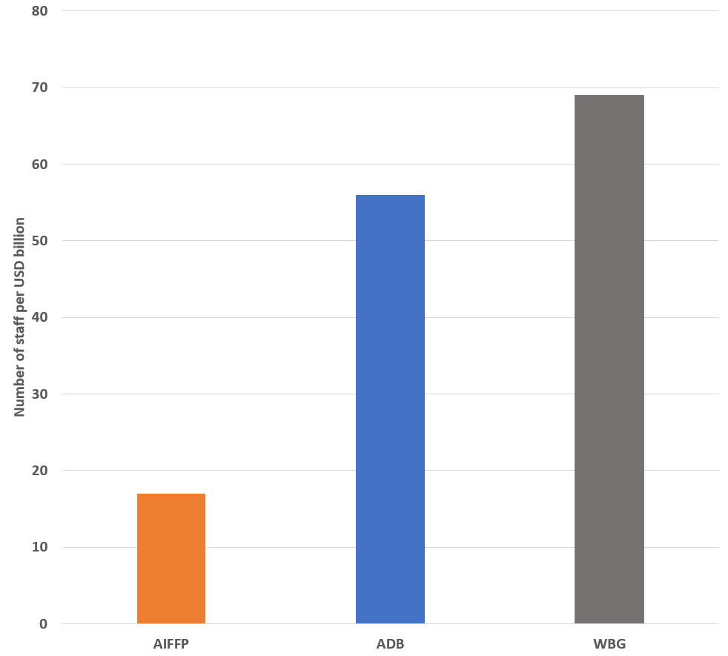

Figure 1: At end-2021, the AIFFP’s staffing-to-portfolio financing ratio was almost five times smaller than that of the World Bank

The Review finds that the current level of AIFFP staff resources poses a risk to the AIFFP achieving its strategic objectives[10]. As highlighted above, the AIFFP is carrying a number of staff vacancies and has set up an external Support Unit to assist it. Even if all the vacant AIFFP positions were filled, and when the recently established Support Unit is functioning effectively, the Review finds that additional AIFFP staff would still be required. This is because many AIFFP projects are moving to implementation, which will require additional resources and skillsets to manage. The Support Unit is also likely to be of limited assistance to some AIFFP sections, such as the Policy and Strategy section, due to the nature of its work.

The Review also finds that the AIFFP resource profile should grow to ensure that risk across the AIFFP’s portfolio is adequately managed. The AIFFP’s Risk Appetite Statement highlights areas where the AIFFP has ‘zero appetite’ for risk-taking. These areas include complying with environmental and social safeguards and engaging quality contractors for implementation. However, the Review team’s view is that the areas responsible for managing such risks are staffed at insufficient levels. In particular, the safeguards team has only 1.5 staff to manage the entire AIFFP investment portfolio (noting these staff can access external contractors).

Interviewees also indicated that implementation capacity is a gap for AIFFP. While it has not been within the scope of this Review to comprehensively assess the skillset required, interviews and the document review suggested that core skills are likely to include:

* + Managing relationships with partners – preferably with staff based in-country;
  + Procurement of infrastructure projects (including support to partners to run procurement processes); and
  + Oversight of contractors and implementation. This includes collecting data to understand construction progress and manage risks appropriately as well as safeguards risks where any issues could cause significant reputational damage to Australia.

Finding 8: Additional staff resources to support AIFFP operations should be sought. For any additional staff resources acquired, consideration should be given to prioritising these to implementation oversight and safeguards.

Some interviewees also suggested that the AIFFP should increase its in-country staff. For example:

* + Pacific partners stated a preference for AIFFP staff to be in-country to build and maintain relationships. They highlighted that other infrastructure lenders have staff in-country, and that AIFFP staff are needed on the ground to ensure that the AIFFP’s support is visible and easily accessible; and
  + DFAT staff at Pacific Posts universally highlighted that they are not sufficiently resourced to assist the AIFFP to achieve its objectives.

In addition, a further area in which the AIFFP’s Risk Appetite Statement outlines ‘zero appetite’ for risk-taking is acting in accordance with the objectives of partner governments. This risk may be more easily managed if AIFFP staff are in-country.

At the same time, there are a number of challenges related to the AIFFP increasing its in-country footprint. There are higher operational costs associated with in-country staff, and such staff will still need to be managed from Canberra. This will likely increase the management and coordination burden on the Canberra-based team. In addition, for smaller Pacific partners which may receive relatively modest support from the AIFFP, it is unclear whether in-country staff are warranted.

Overall, the Review finds that while the idea of increasing the AIFFP’s in-country staff has merit, the AIFFP should experiment with the placement of such staff before determining if this should become a high priority for the facility.

Finding 9: The AIFFP should experiment with the placement of staff in-country to determine if this should become a priority.

Appropriate pipeline of investments

The final factor for exploration under this sub-question focuses on whether an appropriate pipeline of investments is in place. This is discussed in detail under Q1B below. In summary, the Review finds that the AIFFP has an appropriate pipeline of investments which are responding to COVID-19 and are likely to have economic and social benefits.

Q1B: To what extent has THE AIFFP developed an appropriate pipeline of investments, within its overall investment envelope, with good economic and inclusive development potential?

### Summary of key findings

The Review finds that the AIFFP has established an appropriate pipeline of investments with good economic and inclusive development potential. The AIFFP’s timelines for investments are comparable to similar entities (noting a paucity of robust data in this area). The AIFFP is responding appropriately to COVID-19, while the AIFFP’s systems for local employment, GESI, climate change and safeguards are likely to contribute to investments achieving benefits in these areas.

### Factors for exploration

At the Review’s inception stage, the factors for exploration for this sub-question were identified (below). Each of these are discussed in detail below, except for the variability of relative transaction values. It was originally anticipated that the AIFFP’s transaction values would be compared with the transaction values of other infrastructure financiers as part of the benchmarking exercise described in the methodology section. However, this measure was ultimately not included in the benchmarking exercise as data limitations rendered the measure unenlightening; thus, it is not discussed further here.

|  |  |
| --- | --- |
| Sub-question | Factors |
| b. To what extent has the AIFFP developed an appropriate pipeline of investments, within its overall investment envelope, with good economic and inclusive development potential? | If the AIFFP has developed an appropriate pipeline of investments, with good economic and inclusive development potential, we expect to see:   * Benchmarking: More variability in relative transaction values compared with other like financiers (as this is a proxy for funder responsiveness to partner context and needs) * Benchmarking: Comparable or better project timelines, as compared to other like financiers * Landscape analysis: The AIFFP is investing in infrastructure sectors and countries of high need / priority in the Pacific * Investments are responding to the COVID-19 context * Investments are likely to have economic and social benefits, including local employment and gender equality and social inclusion (GESI) benefits * Investments have addressed or will adequately address climate resilience and environmental and social safeguards |

Investment timelines

In the inception phase, it was identified that one aspect of an ‘appropriate’ pipeline was the pace at which investments could be identified, approved, and moved into the construction stage. If the AIFFP was developing an appropriate pipeline, the Review team expected it would be comparable or have better timelines compared to other infrastructure financiers.

The Review team aimed to collected credible quantitative data on timeframes from project approval to construction start for both the AIFFP and other infrastructure financiers. However, it proved challenging to obtain this data from publicly available sources for the majority of infrastructure financiers.

The Review team was able to identify some data from the Northern Australia Infrastructure Facility (NAIF), which provides a useful comparison for the AIFFP. The NAIF is an Australian Government-supported entity which provides loans to infrastructure projects and businesses in northern Australia. It provides a useful comparator for the AIFFP as it is also a government-sponsored entity which was established shortly prior to the AIFFP, noting the NAIF’s remit is domestic rather than international.

When comparing the early stages of the AIFFP and the NAIF, the Review found that the AIFFP had relatively favourable timelines. The NAIF was announced as ‘open for business’ in August 2016. The NAIF board approved its first loan 13 months later, and its second and third loans were both approved by its board 21 months and 22 months respectively after the ‘open for business’ announcement. In contrast, the AIFFP’s board approved its first loan eight months after it was announced as ‘open for business’. The second loan was approved after 10 months, and the third loan after 19 months.

The AIFFP’s timelines also compare favourably with multilateral lenders across the region. For instance, the Asian Infrastructure Investment Bank (AIIB) has made no Pacific or Timorese infrastructure investments to date. This is despite having been operational for three years more than the AIFFP and having access to a capital resource pool many times larger than that of the AIFFP.

Finding 10: The AIFFP’s timelines, from its establishment to the announcement of its initial loans, compare favourably with similar entities.

AIFFP is investing in infrastructure sectors and countries of high need / priority

The Review team examined this factor for exploration because an appropriate pipeline of investment is one which invests in sectors and countries of high development need.

In order to make a judgement about the AIFFP’s effectiveness in this area, the Review team sought to understand which sectors and countries the AIFFP considered to be of high priority. However, the Review team was unable to identify a statement of this nature in the AIFFP Design Document or in subsequent policies and systems. This was expected during the AIFFP’s establishment phase, when it was developing its approach. However, as discussed under Q1A, for the future, the AIFFP may benefit from greater shaping of demand for its loans, which will likely include more explicit statements on countries and sectors of higher priority for the AIFFP.

The above issues notwithstanding, the Review team did collect data on investment countries and sectors for the AIFFP as well as for other similar infrastructure financiers. This is presented below to support greater understanding of the AIFFP’s investments[11].

Figure 2: Infrastructure loans to Pacific partners 2019–2022

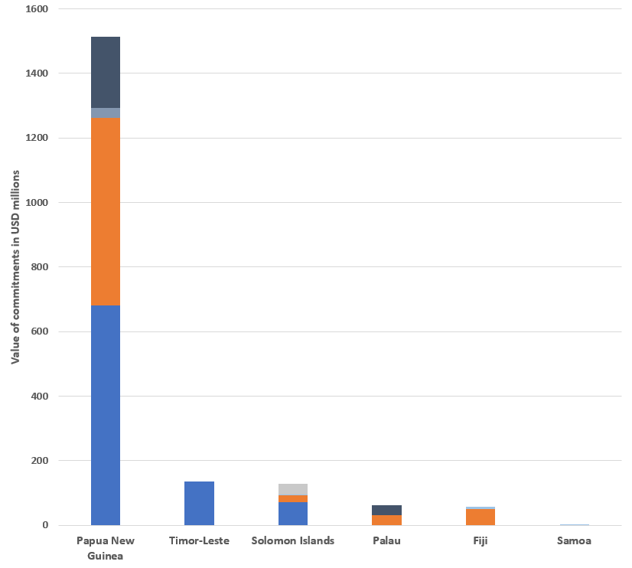

In the three years to 2022, Papua New Guinea was the top Pacific recipient based on the data we collected on infrastructure financiers providing loans to Pacific partners. Papua New Guinea was the top recipient measured both by the number of loans received (11), and by the total committed value of those loans (USD1.514 billion). This places Papua New Guinea significantly ahead of all other recipients, as shown in Figure 2 below. Timor-Leste was the next largest recipient, receiving USD135 million in loan commitments spread across two investments, followed by the Solomon Islands, which received USD127 million in loans, spread across six investments. In the period 2019–2022, Palau, Fiji, and Samoa together account for the remaining USD120 million in loans.

The AIFFP made four investments totalling USD581 million in Papua New Guinea and one investment totalling USD22.88 million in the Solomon Islands.[12] No AIFFP loans were provided to Timor-Leste throughout this period; however, the AIFFP has provided the country with USD6.75 million in grants since 2019.

The Review team also collected data on the infrastructure sectors[13] which financiers invested in. Measured by both total commitment value and project numbers, the “Aviation/Maritime/Transport” sector received the highest volume of funding, with the ADB and the AIFFP expending USD1.378 billion across 11 projects between 2019 and 2022. “Energy/Utilities” investments were the second most popular by both total commitment value and by project numbers, with the ADB, the AIFFP, IBRD, and KEXIM expending USD218 million across seven projects. Among the six financiers that provided loans between 2019 and 2022, “Disaster/Resilience”, “Telecommunications/ICT”, and “Waste/Water/Sanitation/Sewerage” made up the remaining USD50 million in investment.

Of the financiers examined, the AIFFP was the only financier to have invested in the “Telecommunications/ ICT” sector, with a total loan component value of USD8.78 million to Palau in 2020. IDA was the only financier to invest in the “Disaster/Resilience” sector, with three loans totalling USD11.8 million to the Solomon Islands in 2019 and 2021.

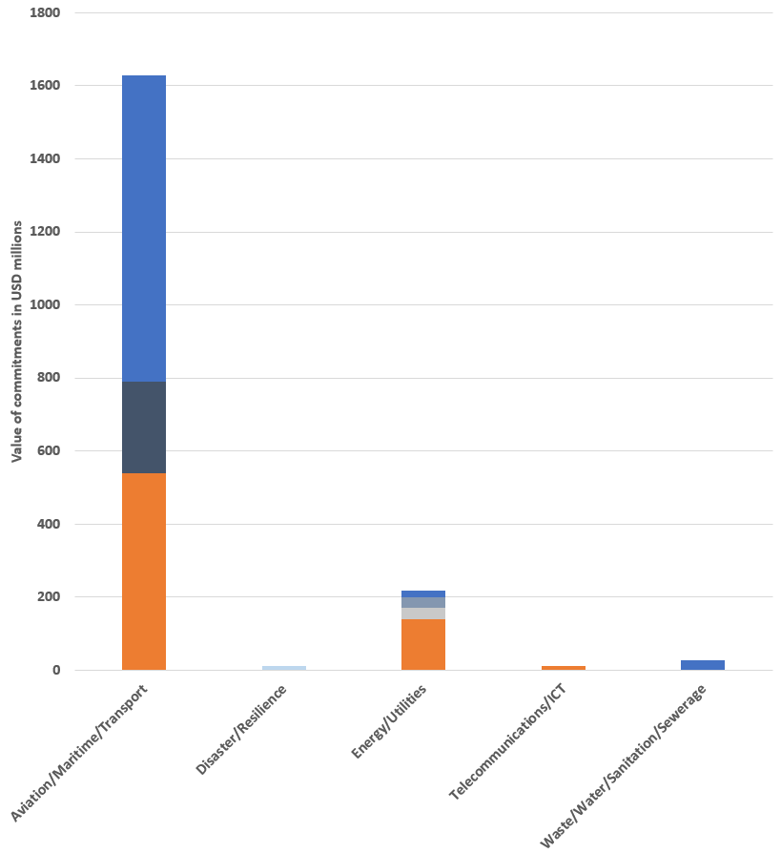

Figure 3: Infrastructure loans in the Pacific by sector, 2019–2022



### Investments responding to the COVID-19 context

Findings for this factor for exploration are discussed in detail under Key Evaluation Question 3 below. In summary, the Review finds that the AIFFP and its investments are responding appropriately to the COVID-19 context, from both a policy perspective and an implementation perspective.

### Investments are likely to have economic and social benefits, and to address climate resilience and environmental and social safeguards: Background

This section of the report examines two factors for exploration together:

* + Investments are likely to have economic and social benefits, including local employment and gender equality and social inclusion (GESI) benefits; and
  + Investments have addressed or will adequately address climate resilience and environmental and social safeguards.

The Review team examined these factors because, as outlined in Q1B, an ‘appropriate’ pipeline is one in which investments have good economic and inclusive development potential.

Q1A discussed a number of AIFFP systems that have been developed during the AIFFP’s establishment phase. Local employment/content, GESI, climate resilience, and environmental and social safeguards are integrated throughout these systems, as discussed below.

Encouraging Pacific-based employment and contracts, or ‘local content’, is strongly encouraged in AIFFP systems. In particular, local participation and capacity building are key principles in the AIFFP procurement system. The AIFFP has also developed strategies for operationalising the focus on local content. For example:

* + Procurement documents include requirements for bidders to develop a Local Labour and Industry Participation Plan which will form part of contractual requirements once the contract is awarded; and
  + The AIFFP is working with the Australia Pacific Technical College (APTC) to help it provide technical and vocational training which is relevant to local industries.

As discussed under Q1A, such approaches by the AIFFP are unique and have the potential to generate economic and social benefits in partner countries.

GESI is also mainstreamed throughout AIFFP systems. For example, the AIFFP Policy Handbook outlines the AIFFP’s approach to GESI, while its safeguards approach (discussed below) outlines that all investments must adhere to DFAT’s GESI safeguards. All investments are also required to have a Gender Action Plan which outlines how an investment will ensure the participation and empowerment of women. In addition, the MEL system integrates GESI considerations. For example, investment-level MEL aims to collect gender-disaggregated data and to measure evidence of gender-specific initiatives.

Climate change is considered throughout AIFFP systems. The AIFFP has a climate change policy and principles which outline that all investment proposals must be assessed for climate risk and disaster risk, and that options for climate-resilient and disaster-resilient design need to be considered. In addition, the AIFFP works together with the Australia Pacific Climate Partnership (APCP), which provides expert climate change input to the investment screening and design phases. It is also envisioned that the APCP will provide input to investment construction.

The AIFFP has a comprehensive safeguards approach which is aligned with EFA’s safeguards approach. For example, AIFFP investments must:

* + Satisfy DFAT’s environmental and social safeguards policy (covering environmental protection, children, vulnerable and disadvantaged groups, displacement and resettlement, indigenous people, and GESI); and comply with partner laws and regulations;
  + Satisfy EFA’s safeguard requirements; and
  + For loans, adhere to International Finance Corporation Performance Standards and associated World Bank Group Environment Health and Safety Guidelines.

The AIFFP has a range of tools to operationalise these requirements. A Safeguards Screening Tool must be completed in the early stages of investment consideration. Each investment must undergo an Environmental and Social Assessment (ESA) prior to approval which addresses the issues and impacts identified during Environmental and Social Due Diligence (ESDD). For each loan, the AIFFP commissions a review by an Independent Environmental and Social Consultant (IESC) to assure ESDD for compliance with both DFAT Safeguards Policy and EFA Safeguards Requirements. Prior to project signing, the AIFFP and the proponent agree to an Environmental and Social Management Plan (ESMP) appropriate to the risk and impacts of the project which outlines partners’ and contractors’ obligations to implement safeguards.

### Investments are likely to have economic and social benefits and address climate resilience and environmental and social safeguards: Findings

The Review finds that policies and systems in place related to economic and social benefits, climate resilience, and environment and social safeguards are high quality and are likely to contribute to investments achieving benefits in these areas (noting that an assessment of implementation is not yet possible). From a review of AIFFP documentation and interviews with staff, it is clear that:

* + Comprehensive and robust policies and systems are in place;
  + The policies and systems are relatively simple to understand and use;
  + The policies and systems are being implemented to the extent that is currently possible. For example, they are included in all Board papers and appear to be seriously considered before investment approval; and
  + All of the areas covered are appropriately integrated across the AIFFP’s multiple investment stages, such as screening, approval and procurement.

Further, as discussed under Q1A above, the AIFFP’s approach of creating contracting opportunities for Pacific businesses is unique and has the potential to generate economic and social benefits in partner countries.

Finding 11: The AIFFP’s policies and systems for economic and social benefits, climate resilience, and environmental and social safeguards are likely to contribute to investments achieving benefits in these areas.

The Review also finds there are three areas where improvements could be considered.

First, the AIFFP should consider mechanisms to improve communication and coordination with relevant programs and partners. The AIFFP has developed and effectively leveraged relationships with partners such as the APTC and the APCP. In interviews, both these partners reflected that earlier notice from the AIFFP on pipeline projects and upcoming tasks would have assisted them to provide better support to the AIFFP. For example, the APTC highlighted that early advice on pipeline investments would assist them to initiate planning of support for partner country training providers in advance of employer demand. This advance notice would enable greater collaboration between all stakeholders and improve the capacity of providers to deliver training in skills that would be relevant for future workforce requirements. Similarly, the APCP also highlighted that earlier advice on upcoming assessments would help to ensure mobilisation of high quality support that would meet the needs of the AIFFP.

The AIFFP could also benefit from increased coordination with other development partners and infrastructure financiers in the Pacific. Such partners may have experiences that the AIFFP could learn from; be able to support large priority projects that are beyond the capacity of the AIFFP; and, as previously noted under Q1A, be able to assist with broader regulatory, capacity and maintenance programs.

Second, while the AIFFP’s policies and systems for gender equality (under the acronym ‘GESI’) are strong, disability inclusion could be developed further. The AIFFP team shared examples of investments that had specific measures for strengthening disability inclusion. However, these project-level examples do not appear to be supported by higher-level frameworks or guidance. For example, specific policies or tools to assist staff to consider disability inclusion are not included in AIFFP policies or SOPs. In addition, disability inclusion was discussed in a meaningful manner in only one of the Board papers examined by the Review team. The AIFFP MEL Plan was one area in which disability inclusion was better integrated, with the MEL Plan aiming, for example, to collect data on outcomes related to disability.

Finding 12: The AIFFP should consider mechanisms to improve communication and coordination with relevant programs/partners and options for increasing disability inclusion guidance in its systems and policies.

Third, in the area of safeguards, opportunity exists for the AIFFP to identify efficiencies and synergies within DFAT and partner safeguards systems to better manage environmental and social risks and impacts. As noted above, AIFFP investments are required to meet both DFAT and EFA safeguards requirements to be endorsed by their respective Boards. The AIFFP and EFA apply similar, though not identical, safeguards standards. At the same time, both AIFFP and EFA Safeguards Policies enable the environmental and social assessment processes of other implementation partners to be used or adapted once they have been reviewed and determined to be broadly equivalent in their objectives, principles and scope.

Different lenders applying their respective standards to the assessment of a project can potentially add an additional layer of complexity to project processing that may delay the process. To date, the AIFFP and EFA have effectively managed this complexity through the commission of IESC compliance reviews of all loans. However, this system can create inefficiencies for the AIFFP and EFA, particularly when an IESC report recommends last-minute changes to investments and associated papers. Given these risks, the Review team questions the value of investments needing to meet both DFAT and EFA safeguards standards. The AIFFP drives and oversees the safeguards process and ensures DFAT’s high standards are met. The quality of DFAT’s standards and the AIFFP’s sound processes suggest that the AIFFP could have greater autonomy in decision-making around safeguards. However, given EFA is lender of record, accepting AIFFP autonomy on decision-making grounds around safeguards may not always be possible.

Finding 13: To increase efficiency and attractiveness to partners, the AIFFP and EFA should explore an agreement to establish an environmental and social due diligence process that includes a level of reliance on the AIFFP’s safeguards systems. However, full reliance may never be possible given EFA’s role as lender of record.

Q1C: How does the AIFFP’s progress compare to that of other infrastructure financiers in the region?

### Summary of key findings

The Review finds that the AIFFP has made good progress since its establishment in 2019 compared to that of other infrastructure financiers in the region. In 2021, the AIFFP was the second-largest infrastructure financier in the Pacific by financing value and number of projects. Among indicators of inclusiveness – such as the availability of policies related to GESI, climate resilience, and social safeguards – the AIFFP performs above average compared to other financiers.

At the inception stage, specific factors for exploration for this sub-question were not developed. As part of the benchmarking exercise described in the methodology, the Review team, together with the AIFFP, identified a set of key measures to assess the AIFFP’s progress in comparison to other infrastructure financiers in the region. These included the total value of committed funds, the total number of loans, and inclusiveness scores. Each of these measures is discussed below.

### Total value of committed funds

Following its establishment in 2019, the AIFFP has grown the value of its committed loan expenditure by an average of 370% year on year, leading it to become, in 2021, the region’s second-largest financier of loans after the ADB.

Since being declared open for business in 2019, the AIFFP has committed (via both loan and grant financing) just over 53% of its original asset value of AUD2 billion[14]. Although it has been operational for three years longer than the AIFFP, the NAIF committed only 59% of its total asset value between 2016 and 2021.

**Figure 4: In 2020, the AIFFP became the region's second-largest infrastructure financier**[15]

Total number of loans

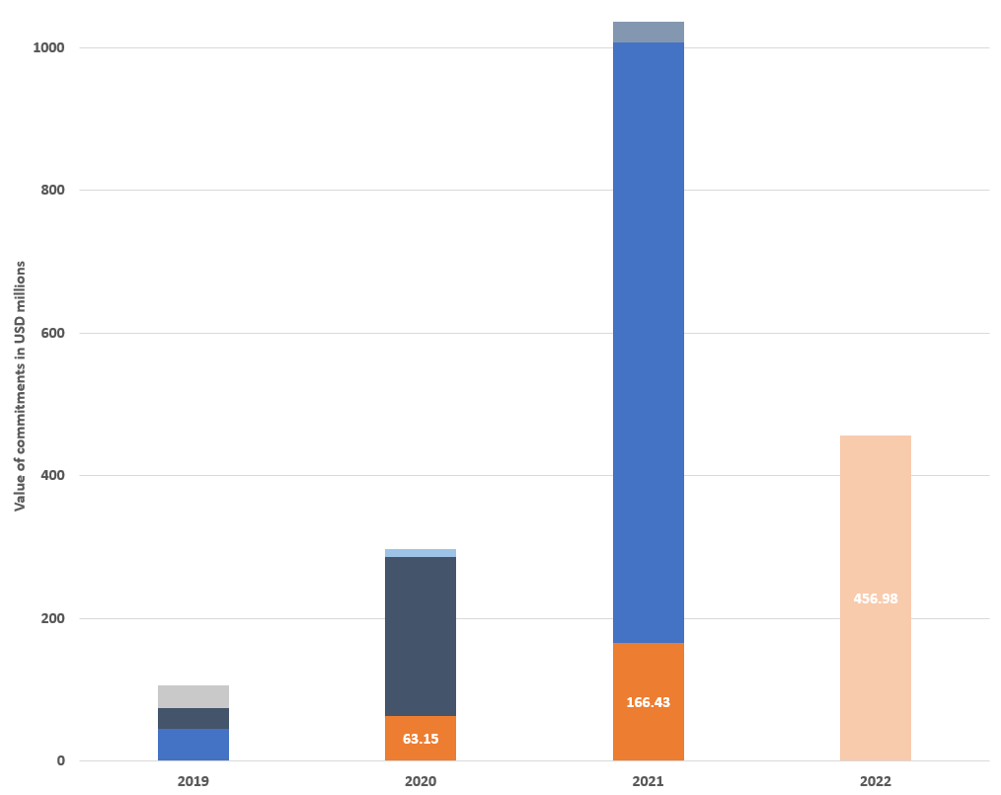

Measured by the number of loans provided between 2019 and 2022, the AIFFP’s project portfolio of eight loans[16] is second only to that of the ADB (which invested in a total of 10 loans). The AIFFP scores almost 2.5 times above our sample’s modal value of three loans, or 43% higher than our sample’s average of 3.5 loans. In the same period, the NAIF initiated 18 loans, or 20% more than the number originated by the AIFFP.

Figure 5: The AIFFP has the region's second-largest project portfolio

### Inclusiveness scores

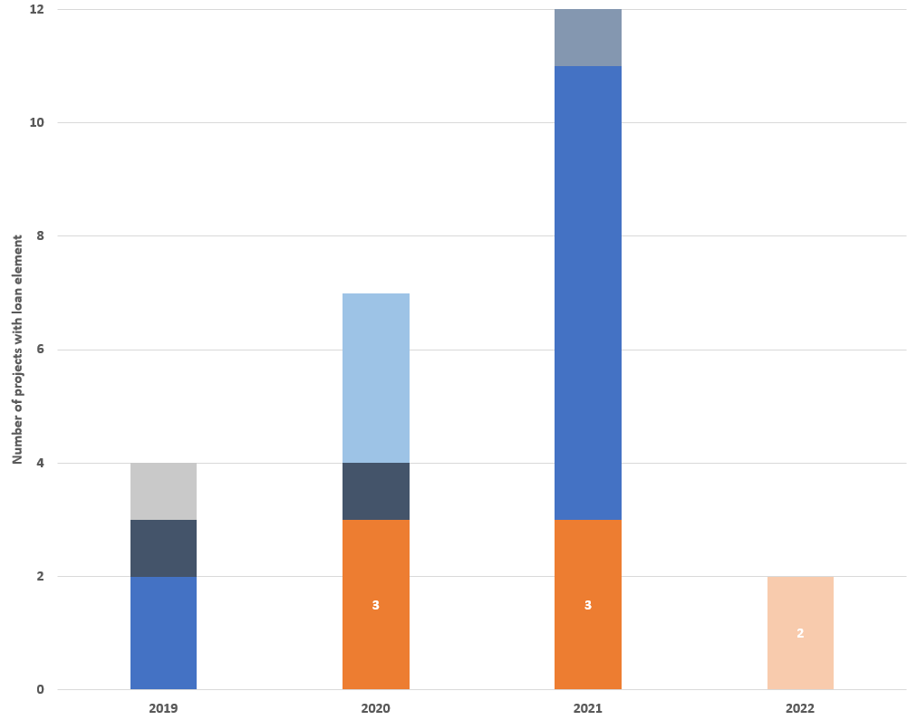

The Review team examined nine inclusiveness indicators which were binary coded, meaning financiers could score only “Yes” or “No” for each measure. Among indicators of inclusiveness, the AIFFP performs above average, receiving positive ratings for all measures and providing it with an overall score of 100%. This makes the AIFFP one of only four financiers, and the only non-multilateral development bank, to have achieved a perfect inclusiveness score (the others being the ADB, IDA, and IBRD). The table below provides an overview of the inclusiveness measures, the AIFFP’s scores, and the percentage of financiers that achieved a positive (“Yes”) score for each indicator.

The table shows that Among indicators of inclusiveness, the AIFFP performs above average compared to other infrastructure financiers, receiving positive ratings for all measures and providing it with an overall score of 100%. This makes the AIFFP one of only four financiers, and the only non-multilateral development bank, to have achieved a perfect inclusiveness score. 

Finding 14: The AIFFP has made good progress since its establishment in 2019 when compared to that of other infrastructure financiers in the region.

# Key Evaluation Question 2: Is the AIFFP on track on long-term strategic program outcomes and objectives?

This section discusses the AIFFP’s progress towards its strategic objectives. It focuses on three sub-questions and the factors for exploration which were defined under these sub-questions.

The AIFFP MEL Plan outlines the AIFFP’s three strategic objectives:

* + Pacific countries have increased access to capital to support quality, resilient, and inclusive economic infrastructure;
  + Australia delivers infrastructure financing that meets the development needs of Pacific countries; and
  + Australia is a partner of choice for financing infrastructure in the Pacific.

Q2A: To what extent will AIFFP investments support quality, resilient and inclusive infrastructure in the Pacific?

### Summary of key findings

The Review finds that AIFFP investments are likely to support quality, resilient and inclusive infrastructure in the Pacific. This is because the AIFFP has an appropriate pipeline of investments in place (as discussed under Q1B and has built strong relationships with Pacific partners.

### Factors for exploration

At the Review’s inception stage, the following factors for exploration for this sub-question were identified. Two of these are discussed in detail below.

In the inception phase, ‘Pacific partners demonstrate a commitment to maintaining infrastructure in the long term’ was seen as an important factor for exploration as it could provide an indication that infrastructure would be sustainable in the long term. During data collection, it became apparent that it was challenging to collect credible data on this factor as, given the early stages of investment implementation, the Review team could rely only on interview data with Pacific partners. As a result, this factor is not discussed further.

|  |  |
| --- | --- |
| **Sub-question** | **Factors** |
| a. To what extent will AIFFP investments support quality, resilient and inclusive infrastructure in the Pacific region? | If AIFFP investments are likely to support quality, resilient, and inclusive infrastructure in the Pacific region, we expect to see:   * An appropriate pipeline of investments is in place as addressed under Q1B – particularly the factors related to country needs, COVID-19, and economic and inclusive development potential; * Strong relationships between the AIFFP and Pacific partners; and * Pacific partners demonstrate a commitment to maintaining infrastructure in the long term. |

Appropriate pipeline of investments

The Review team included this factor for exploration because in order for the AIFFP to support quality infrastructure a strong pipeline needs to be in place.

The Review finds that the AIFFP has an appropriate pipeline of investments in place (Q1B discussion). In particular, the AIFFP is responding to the COVID context and has policies and systems in place related to economic and social benefits, climate resilience, and environment and social safeguards which are high quality and are likely to contribute to investments achieving benefits in these areas.

AIFFP-Pacific relationships

The Review team explored this factor as it was identified that strong relationships between the AIFFP and Pacific partners are needed in order for quality, resilient and inclusive infrastructure to be delivered.

In interviews, Pacific partners (both sovereign and private sector) who are receiving financing from the AIFFP reflected very positively on the quality and responsiveness of AIFFP staff; they shared that this has led to strong relationships between the AIFFP and Pacific partners. Interviewees noted that:

* + AIFFP staff have worked effectively with Pacific partners. They have communicated clearly, they understand the Pacific context, they have taken culturally sensitive approaches, and they are focused on solving problems;
  + AIFFP staff were focused on action and saw a clear need to work closely together with their partners;
  + AIFFP staff have assisted partners to understand and interpret infrastructure loan arrangements. This “soft” technical assistance supported increased capacity in the Pacific markets in which the AIFFP has engaged; and
  + The AIFFP has been responsive to, and willing to engage with, Pacific partners’ self-identified infrastructure financing needs, as opposed to superimposing an Australian-centric investment agenda on prospective partners.

The majority of DFAT Posts in the Pacific supported the perspective of Pacific partners, sharing that the quality of AIFFP staff is high. AIFFP staff were recognised for their strong technical expertise, sound advice, responsiveness, and ability to build strong relationships with Pacific partners.

Finding 15: The AIFFP has built strong relationships with a number of Pacific partners.

At the same time, for a small number of Pacific Island countries, DFAT Posts shared their perceptions that strong relationships have not been established with Pacific partners. Interviewees outlined that:

* + The expectations of partner governments were raised by the idea that the AIFFP would be able to meet infrastructure financing needs; however, to date some partners perceive that their expectations have not been met; and
  + For one of the Pacific partners, Post outlined that AIFFP discussions with the partner were not always directed through the DFAT Post, which caused strained relationships between the Post and the partner government.

The Review team was unable to verify this information with Pacific partners themselves. However, these points highlight that although good relationships currently exist with a number of Pacific partners, there are risks to the AIFFP building and maintaining high-quality relationships. These risks are discussed further under Q2B below.

Q2B: Is the AIFFP positioning Australia as a partner of choice for financing infrastructure, including shaping of demand for quality infrastructure, in the Pacific region?

### Summary of key findings

The Review finds that the AIFFP has positioned itself as a partner of choice in the Pacific. The AIFFP has established an appropriate pipeline of investments, and Pacific partners express positive sentiment about the AIFFP and its approaches, with some expressing a clear preference for working with the AIFFP. To date, the AIFFP has been able to offer attractive and competitive financing. To continue on this positive trajectory, the AIFFP should consider how it can set clearer expectations for partners on the timeframes required for investment approval. In addition, it should investigate options for improving the competitiveness of its loans.

### Factors for exploration

At the Review’s inception stage, the following factors for exploration for this sub-question were identified. Each of these are discussed in detail below.

|  |  |
| --- | --- |
| **Sub-question** | **Factors** |
| b. Is the AIFFP positioning Australia as a partner of choice for financing infrastructure, including shaping of demand for quality infrastructure, in the Pacific region? | If the AIFFP is positioning Australia as a partner of choice, and shaping demand for quality infrastructure in the Pacific region, we would expect to see:   * Landscape analysis: the AIFFP is investing in sectors and countries of high need / priority in the Pacific * Benchmarking: the AIFFP’s market competitiveness measures and investment performance measures are comparable to or better than those of other financiers * An appropriate pipeline of investments is in place (as addressed under Q1B) * Pacific partners demonstrate a preference for working with the AIFFP over other funders / financiers * Pacific partners express positive sentiment about the AIFFP * Pacific partners are aiming to incorporate AIFFP approaches in areas such as local employment, GEDSI, climate resilience, and social and environmental safeguards, into other projects. |

AIFFP investments in sectors/countries of high need/priority in the Pacific; and appropriate pipeline of investments

The Review team included these factors for exploration because a pre-requisite for the AIFFP to be a partner of choice is that it is investing in countries and sectors of high need in the Pacific and has an appropriate pipeline of investments in place.

As outlined under Q1B, the Review finds that the AIFFP has an appropriate pipeline of investments in place, with timelines being comparable to those of other similar entities and with investments being likely to achieve benefits in areas such as local employment, GESI and climate change.

AIFFP market competitiveness measures and performance

This factor for exploration was included because, if the AIFFP is to be a partner of choice, it should provide loan financing which is competitive with other multilateral and bilateral financiers which operate in the Pacific.

The AIFFP and EFA face challenges in providing competitive loans (Q1A discussion). EFA issues loans on behalf of the AIFFP from the National Interest Account, which under current government policy must cover EFA’s costs of funding and administering the loan. As a result, the AIFFP struggles to be competitive in terms of its headline interest rates, with other lenders able to offer highly concessional loans, including loans that do not cover their funding costs and make losses.

To mitigate this competitiveness challenge, the AIFFP has some mechanisms to improve the attractiveness of its loans. For example:

* + The AIFFP can provide a combination of loans and grants to its partners, resulting in a package of financing which is more concessional than it could offer via a standalone loan. In these cases, EFA issues the loan and the AIFFP provides the grant through DFAT systems. While this blended approach enhances the attractiveness and competitiveness of the overall financing package, the separate agreements can be administratively complex for the recipient and the higher nominal interest rate on the loan component presents refinancing risks;
  + The AIFFP is more flexible than other financiers in its loan terms. It has accepted that its loans do not benefit from preferred creditor statuses and enabled recipients’ significant customisation of repayment terms (including grace periods and capitalisation of interest); and
  + The AIFFP has a strong focus on encouraging local contractors. While it plans to encourage its partners to engage contractors from the DFAT Capital Infrastructure Services Panel, the AIFFP does not require partners to use Australian firms for construction and oversight. By contrast, a number of bilateral financiers have policies which preference their domestic contractors[17].

Based on interview data, it appears that the AIFFP’s approach to ensuring it is competitive has been relatively successful to date. In interviews, Pacific partners were generally satisfied with the terms of their loans and stated that interest rates on offer were competitive. However, the AIFFP has received feedback from senior members of Pacific governments that its loans are expensive.

At the same time, there are risks to the AIFFP maintaining its competitiveness in the future. The AIFFP grant funding available to create more concessional loan/grant packages will reduce over time, given that some Pacific partners are eligible for grants only and grants are also needed for project preparatory work. In addition, issuing parallel grants and loans may create challenges for partners who need to draw down and report on these funds in different ways. Further, in the context of rapidly rising global interest rates, which affect EFA’s (and the Commonwealth’s) funding costs, it will become more expensive for the AIFFP to offer attractive loans or loan/grant packages when loans must cover funding costs. This could lead to AIFFP loans becoming significantly more expensive than the highly concessional fixed interest rates offered by other financiers and indeed, even the ‘non-concessional’ rates offered by MDBs.

The Review finds that the AIFFP would be more competitive, and more likely to be a ‘partner of choice’, if in addition to its existing suite of financing products it could offer a straight loan product at a highly concessional interest rate (preferably fixed), even if this would be below EFA’s funding costs. This view was also supported by Pacific partners who are currently receiving AIFFP support; they shared that they would like interest rates to be as low as possible.

Finding 16: The AIFFP should propose to the Australian Government options to improve the competitiveness of the AIFFP’s loans, with a particular focus on the headline interest rate and the ease of borrowing for partners.

Pacific partners’ sentiments about and preference for working with the AIFFP

To obtain evidence on whether the AIFFP is viewed as a partner of choice, the Review team examined the extent to which Pacific partners expressed a preference for working with the AIFFP and noted their positive sentiments about the AIFFP.

As noted above, the AIFFP has established strong relationships with Pacific partners, particularly those working closely with the AIFFP. In interviews, a small number of these partners expressed a clear preference for working with the AIFFP. They highlighted that the AIFFP is currently the highest-performing group that they work with; that they prefer to work with the AIFFP compared to other infrastructure financiers; and that the AIFFP’s bureaucracy is generally less burdensome compared to that of other financiers. In interviews where partners did not express a preference for working with the AIFFP, they generally shared that the AIFFP performed similarly to other infrastructure financiers.

Finding 17: A number of Pacific partners express a clear preference for working with the AIFFP.

Although some Pacific partners expressed a preference for the AIFFP, there are some risks to the AIFFP achieving its objective of being a partner of choice in the Pacific. Some of these risks are discussed directly above and under Q2A.

In addition, even Pacific partners who expressed a preference for working with the AIFFP shared that the timelines for investment approval were slow and cumbersome. Pacific partners struggled to understand why multiple approvals from the AIFFP, EFA and the Australian Government were required. They also felt that the long approval timelines were counter to political imperatives in their countries (for example, political preferences to announce new infrastructure projects as early as possible).

As previously discussed, the AIFFP could consider alternative operating models that may help address the approval process in the longer term. It has also been previously discussed that the AIFFP approval timelines are better than those of similar financiers, such as the NAIF. This suggests that, more immediately, it may be useful for the AIFFP to set clearer expectations for partners on the likely timeframes for investment approval. This could include, for example:

* + Ensuring Pacific partners and DFAT Posts have visibility of the AIFFP’s processes by sharing appropriate or tailored sections of the AIFFP’s Standard Operating Procedures; and
  + Considering providing data to partners on project preparation and approval timelines from earlier investments.

Finding 18: The AIFFP should consider how it can set clearer expectations with Pacific partners on the likely timeframes for investment approval.

Pacific partners aiming to incorporate AIFFP approaches

Through this factor for exploration, the Review team sought to understand if Pacific partners were incorporating AIFFP approaches (for example, on environmental and social safeguards and local employment/content) into non-AIFFP infrastructure projects. This would provide evidence on whether the AIFFP is shaping demand for quality infrastructure in the Pacific.

From interviews with Pacific partners, it is clear that they value the AIFFP’s approaches. Pacific partners noted that the AIFFP upholds strong environmental and social safeguards, and that these safeguards must be met before funds are approved. Partners recognised that such safeguards were beneficial and would lead to better infrastructure projects. Partners were also very positive about the AIFFP’s approach to local employment. Pacific partners highlighted that the AIFFP is assisting them to consider how funds could be appropriately directed towards local businesses, and that the AIFFP performed much better than other financiers in this area.

At the same time, it was difficult to obtain credible evidence that Pacific partners were incorporating the AIFFP’s approaches into other infrastructure projects. This is not surprising given the early stages of many of the AIFFP’s projects. The Review team suggests that the AIFFP should consider ongoing monitoring in this area as it may provide future evidence of the effectiveness of the AIFFP’s approaches.

Q2c: To what extent are AIFFP investments responding to the infrastructure development needs of Pacific Island countries?

### Summary of key findings

The Review finds that the AIFFP is responding appropriately to the infrastructure development needs of Pacific Island countries. The AIFFP has made additional financing available in the Pacific, and Pacific partners view the AIFFP positively and perceive it to be responding to their needs.

### Factors for exploration

At the Review’s inception stage, the following factors for exploration for this sub-question were identified.

|  |  |
| --- | --- |
| **Sub-questions** | **Factors** |
| c. To what extent are AIFFP investments responding to the infrastructure development needs of Pacific island countries? | If AIFFP investments are responding to the infrastructure development needs of Pacific Island countries, we expect to see:   * Landscape analysis: the AIFFP is investing in sectors and countries of high need / priority in the Pacific and affecting infrastructure financing flows to the Pacific * The AIFFP is responding to the needs of partner governments * Pacific partners demonstrate a preference for working with the AIFFP over other funders / financiers * Pacific partners express positive sentiment about the AIFFP |

The factors for exploration outlined under this Key Evaluation Question are covered in previous sections of the report. Based on those sections, the Review found that AIFFP investments are responding appropriately to the infrastructure development needs of Pacific partners. This is evident in the following ways:

* + Although the Review team was unable to assess if the AIFFP is investing in countries and sectors of high priority (Q1B discussion), the AIFFP has made additional finance available in the Pacific and was the Pacific’s second-largest infrastructure financier in 2020 (Q1C discussion).
  + Pacific partners demonstrate a preference for working with the AIFFP, express positive sentiments about the AIFFP, and perceive that the AIFFP is responding to their priorities (outlined under Q2A and Q2B).

# Key Evaluation Question 3: What Challenges Have Been Encountered and What Lessons Have Been Learned?

The Review did not develop factors for exploration for this Key Evaluation Question. Instead, an open-ended, exploratory approach to its sub-questions was taken.

Q3a: How have significant environmental changes since the AIFFP design in 2019 (specifically COVID-19) impacted on AIFFP delivery – or alternatively, provided opportunity for experimentation?

### Summary of key findings

The Review finds that the AIFFP has responded well to the COVID-19 pandemic. The AIFFP updated its policies to ensure its investments could assist Pacific partners to respond to COVID-19 and stabilise their economies; it carefully considers COVID-19 responses and impacts in investment Board papers; and it has adapted well to the challenges of operating during a pandemic.

The major environmental change which has influenced the AIFFP since its establishment was the COVID-19 pandemic. The AIFFP responded to this challenge from a policy and systems perspective and through its operations.

In its policy response, the AIFFP updated its policy framework to broaden the scope of the investments that it can support. The AIFFP can assist Pacific partners to respond to COVID-19 and stabilise their economies by supporting investments which:

* + are labour-intensive and can be implemented quickly;
  + consider infrastructure from a broader range of sectors, including tourism and social infrastructure, particularly health infrastructure;
  + increase local procurement, employment and skills development within local workforces as part of infrastructure delivery; and
  + deliver ‘last mile’ infrastructure which connects businesses and households to infrastructure services.

In addition to updating its policy framework, it is clear that the AIFFP carefully considers COVID-19 from an investment decision perspective. AIFFP Board papers reviewed by the Review team examined how a proposed investment could contribute to a partner country’s recovery from COVID-19. In particular, local content and employment were key considerations in investment papers. Further, how COVID-19 may impact partner countries’ debt distress and/or a partner’s ability to service a loan was a key consideration in AIFFP Board papers.

The AIFFP also adapted well to the challenges of working in a pandemic. Similar to other programs, AIFFP staff experienced challenges such as the inability to travel. The availability of partner staff was also reduced at times due to a shift in focus towards a pandemic response in their organisations. However, in interviews Pacific partners reflected that the AIFFP continued to interact regularly and work well with partners virtually. They felt that COVID-19 had not significantly slowed progress. This view was supported by a number of AIFFP staff who shared that, while working in the pandemic had been challenging, considerable progress on investments continued to be made.

Finding 19: The AIFFP has responded well to the COVID-19 pandemic.

Q3B: What are the priorities for Change and strengthening based on lessons and experience to date?

### Summary of key findings

The Review finds that the AIFFP continually seeks to identify lessons and improve for the future through the use of internal information sessions, performance discussions and reflection workshops.

The AIFFP has a robust MEL system which encourages continuous learning and improvement across the AIFFP (as noted under Q1A). This learning approach has been operationalised in a number of ways, including:

* + Regular ‘brown-bag lunch’ sessions (or internal information sharing sessions) where AIFFP staff share lessons and experiences related to particular topics. The AIFFP has conducted at least 36 of these sessions since mid-2020; and
  + Regular performance discussions, reflection workshops and planning days. These collaborative events aim to identify what is working well in the AIFFP as well as areas for improvement.

In a positive development, these brown-bag lunches and reflection/planning processes have already discussed a number of topics raised in this review. For example, brown-bag lunch sessions have included discussion on the systems described in this report, including due diligence, investment and AIFFP-wide MEL, procurement (multiple sessions), social safeguards, local content, and risk management. They have also included sessions provided by Australian Government partners (IPFA, Treasury) and have showcased specific investments to provide opportunities for learning.

The most recent reflection workshop, held in August–September 2021, identified lessons and ideas that could be immediately incorporated into the AIFFP team’s work. Examples include delivering new deals in tight timeframes with limited staff resources; how to work effectively with the new Support Unit; and how AIFFP systems can be improved and streamlined. In addition, this reflection workshop also identified issues that were referred to this Review for deeper consideration. These included the AIFFP’s operating model, governance and market competitiveness.

The Review team understands that the AIFFP is actively considering how it can develop and make accessible case studies on topics of relevance across the AIFFP. A key example is the Palau Solar investment. Due diligence processes highlighted that there was a risk of forced labour in the investment’s supply chain, leading to changes to the project to reduce this risk. This scenario brought to the fore the critical role that due diligence procedures play in promoting safeguards standards, and resulted in the AIFFP applying innovative blended finance arrangements. The details of this process will be captured in a document to be shared across the AIFFP and within DFAT to promote continuous learning.

These examples all highlight that the AIFFP is continually seeking to identify lessons, learn from these lessons, and improve for the future.

Finding 20: The AIFFP is continually seeking to identify lessons and improve for the future.

This Review has built on the AIFFP’s focus on identifying lessons and learning from these lessons by identifying a number of lessons and priorities for change. These are highlighted throughout the report as findings and are summarised in the Conclusion section below.

Conclusion

This report has identified 20 key findings. The findings below relate to the achievements of the AIFFP since its establishment in 2019:

* + Finding 1: To date, the AIFFP architecture has enabled the AIFFP to make good progress.
  + Finding 3: The AIFFP has made considerable and impressive progress in its establishment phase to develop high-quality systems that meet its needs.
  + Finding 7: AIFFP staff are high quality and have built strong relationships with Pacific partners.
  + Finding 10: The AIFFP’s timelines, from its establishment to the announcement of its initial loans, compare favourably with similar entities.
  + Finding 11: The AIFFP’s policies and systems for economic and social benefits, climate resilience, and environmental and social safeguards are likely to contribute to investments achieving benefits in these areas.
  + Finding 14: The AIFFP has made good progress since its establishment in 2019 when compared to that of other infrastructure financiers in the region.
  + Finding 15: The AIFFP has build strong relationships with a number of Pacific partners.
  + Finding 17: A number of Pacific partners express a clear preference for working with the AIFFP.
  + Finding 19: The AIFFP has responded well to the COVID-19 pandemic.
  + Finding 20: The AIFFP is continually seeking to identify lessons and improve for the future.

Other findings relate to areas in which the AIFFP should consider action in order to improve or manage risks in the future. These constitute the recommendations from this Review and have been divided into two categories.

The first set of recommendations are the highest priority recommendations from this Review. They are areas in which, according to the Review team, action should be prioritised to enable the AIFFP to achieve its strategic objectives in the long term.

|  |  |
| --- | --- |
| **Recommendation #** | **Finding / Recommendation** |
| Recommendation 1 | Finding 8: Additional staff resources to support AIFFP operations should be sought. For any additional staff resources required, consideration should be given to prioritising these to implementation oversight and safeguards. |
| Recommendation 2 | Finding 9: The AIFFP should experiment with the placement of staff in-country to determine if this should become a priority. |
| Recommendation 3 | Finding 16: The AIFFP should propose to the Australian Government options to improve the competitiveness of the AIFFP’s loans, with a particular focus on the headline interest rate and the ease of borrowing for partners. |
| Recommendation 4 | Finding 2: For the longer term, the AIFFP could explore the Australian Government’s appetite for operating models which may increase the AIFFP’s efficiency. |

Other recommendations from the Review are outlined below. These focus on improving the AIFFP’s effectiveness and efficiency, its relationship with partners, and its operations.

|  |  |
| --- | --- |
| **Recommendation #** | **Finding / Recommendation** |
| Recommendation 5 | Finding 6: The AIFFP should consider how appropriate policy and regulatory environments, and provisions for longer-term maintenance, can be supported in partner countries to ensure the AIFFP can achieve its long-term objectives. |
| Recommendation 6 | Finding 13: To increase efficiency and attractiveness to partners, the AIFFP and EFA should explore an agreement to establish an environmental and social due diligence process that includes a level of reliance on the AIFFP’s safeguards systems. However, full reliance may never be possible given EFA’s role as lender of record. |
| Recommendation 7 | Finding 5: The AIFFP should consider how it can share demand from partners for investments in high-priority sectors and countries. |
| Recommendation 8 | Finding 18: The AIFFP should consider how it can set clearer expectations with Pacific partners on the likely timeframes for investment approval. |
| Recommendation 9 | Finding 12: The AIFFP should consider mechanisms to improve communication and coordination with relevant programs/partners and options for increasing disability inclusion guidance in its systems and policies. |
| Recommendation 10 | Finding 4: The AIFFP should finalise the IMS as an immediate priority. |

Annexes

# Annex 1: Evaluation Framework

The data requirements and process for addressing the Key Evaluation Questions are summarised in the table below.

**1. What has AIFFP achieved to date?**

| **Key Evaluation Question** | **Evidence / information required (also known as ‘factors for exploration’)** | **Data sources** | **Data collection and analysis approach** |
| --- | --- | --- | --- |
| a. To what extent is the AIFFP office operating *effectively* and *efficiently* to source, select and implement investments? | AIFFP architecture – specifically on the operating model and governance  AIFFP systems - specifically risk management, cross-team planning, and MEL  AIFFP staffing – specifically staff resources, staff skills, team composition, and team structure  An appropriate pipeline of investments is in place as addressed under Q1B | AIFFP documents, particularly the 2020 systems review, risk management documents, MEL documents  DFAT staff  Pacific partners | Desk review of AIFFP documents  Interviews with DFAT staff and Pacific partners  Analysis of the extent to which data supports the presence of the factors for exploration |
| b. To what extent has the AIFFP developed an appropriate pipeline of investments, within its overall investment envelope, with good economic and inclusive development potential? | Benchmarking: More variability in relative transaction values compared with other like financier  Benchmarking: Comparable or better project timelines, as compared to other like financiers  Landscape analysis: the AIFFP is investing in infrastructure sectors and countries of high need / priority in the Pacific  Investments are responding to the COVID-19 context  Investments are likely to have economic and social benefits, including local employment and gender equality, disability and social inclusion (GEDSI) benefits  Investments have addressed or will adequately address climate resilience, environmental, and social safeguards | Landscape analysis  Benchmarking exercise  DFAT and AIFFP documents, particularly on priority countries and infrastructure sectors; AIFFP policy documents on economic and social benefits + environmental and social safeguards; AIFFP investment documents on economic and social benefits + environment and social safeguards  DFAT staff  Pacific partners | Review of results from landscape analysis and benchmarking exercise  Desk review of DFAT and AIFFP documents  Interviews with DFAT staff and Pacific partners  Analysis on the extent to which data supports that the factors for exploration are present |
| c. How does the AIFFP’s progress compare to that of other infrastructure financiers in the region? | Key indicators to be collected is outlined in the benchmarking template | Asian Development Bank - projects and tenders  AidData – Chinese lending  AIFFP – Investments  Asian Infrastructure Investment Bank – project list  European Investment Bank – global investment map  International Bank for Reconstruction and Development / International Development Association – projects, net flows and commitments  International Finance Corporation  Japan International Cooperation Agency – ODA Loans  Lowy Institute – Pacific Aid Map  Northern Australia Infrastructure Facility – Case Studies  Other sources identified during the landscaping and benchmarking exercises | Review publicly available sources as outlined in the previous column  Complete benchmarking template  Construct scales for each indicator and mark performance for the AIFFP and other financiers against each scale |

**2. Is the AIFFP on track to deliver on long-term strategic program outcomes and objectives?**

| **Key Evaluation Question** | **Evidence / information required (also known as ‘factors for exploration’)** | **Data sources** | **Data collection and analysis approach** |
| --- | --- | --- | --- |
| a. To what extent will the AIFFP investments support quality, resilient and inclusive infrastructure in the Pacific region? | An appropriate pipeline of investments is in place, as addressed under Q1B  Strong relationships between the AIFFP and Pacific partners  Pacific partners demonstrate a commitment to maintaining infrastructure in the long-term | Findings for Q1B  DFAT staff  Pacific partners | Review findings for Q1B  Interviews with DFAT staff and Pacific partners  Analysis on the extent to which data supports that the factors for exploration are present |
| b. Is the AIFFP positioning Australia as a partner of choice for financing infrastructure, including shaping of demand for quality infrastructure, in the Pacific region? | Landscape analysis: AIFFP is investing in sectors and countries of high need / priority in the Pacific  Benchmarking: the AIFFP’s market competitiveness measures and investment performance measures are comparable to or better than other financiers  An appropriate pipeline of investments is in place as addressed under Q1B  Pacific partners prefer to work with the AIFFP over other funders/financiers  Pacific partners express positive sentiment about AIFFP  Pacific partners are aiming to incorporate AIFFP approaches in areas such as local employment, GEDSI, and social and environmental safeguards, into other projects | Landscape analysis  Benchmarking exercise  DFAT staff  Pacific partners  AIFFP Communications and Public Diplomacy Pilot Project | Review of results from landscape analysis and benchmarking exercise  Review of AIFFP social media study  Interviews with DFAT staff and Pacific partners  Analysis on the extent to which data supports that the factors for exploration are present |
| c. To what extent are AIFFP investments responding to the infrastructure development needs of Pacific island countries? | Landscape analysis: The AIFFP is investing in sectors and countries of high need / priority in the Pacific, and is disrupting previous trends in infrastructure financing flows to the Pacific  The AIFFP is responding to the needs of partner governments  Pacific partners prefer to work with the AIFFP over other funders / financiers  Pacific partners express positive sentiment about the AIFFP | Landscape analysis  Benchmarking exercise  DFAT staff  Pacific partners | Review of results from landscape analysis  Review of AIFFP social media study  Interviews with DFAT staff and Pacific partners  Analysis on the extent to which data supports that the factors for exploration are present |

**3. What challenges have been encountered and what lessons have been learned?**

| **Key Evaluation Question** | **Evidence / information required (also known as ‘factors for exploration’)** | **Data sources** | **Data collection and analysis approach** |
| --- | --- | --- | --- |
| a. How have significant environmental changes since the AIFFP design in 2019 (specifically COVID-19) impacted on AIFFP delivery – or alternatively, provided opportunity for experimentation and innovation? | Impact of COVID-19 on AIFFP delivery  Response by the AIFFP (facility overall and individual investments) to COVID-19  Other contextual factors that may have affected the AIFFP, and the facility/investment responses | DFAT staff  Pacific partners | Interviews with DFAT staff and Pacific partners |
| b. What are the priorities for change and strengthening based on lessons and experience to date? | Open-ended exploration of this question | DFAT staff  Pacific partners | Desk review of AIFFP documents, particularly record of performance discussions, reflection workshops and brown-bag sessions  Interviews with DFAT staff and Pacific partners  Summary of findings from other evaluation questions |

# Annex 2: AIFFP Operating Models

This Review has not been tasked with developing or recommending alternative operating models for the AIFFP. However, in the course of interviews, the Review team heard ideas for alternative operating models. These appear below for further consideration by the AIFFP; however, the Review team has not investigated the advantages and disadvantages of any of these approaches in depth.

Idea 1: The AIFFP remains within DFAT

One idea presented was that AIFFP could remain within DFAT with small adjustments to the existing model, such as developing a highly concessional loan product priced below the cost of funds (as discussed in the body of the report) and allowing AIFFP’s overseas development assistance to be provided directly to EFA so it can provide a single flow of funds to sovereign partners. This, along with additional grant funding, would help address the AIFFP’s competitiveness relative to other highly concessional lenders.

An alternative approach would be to keep the AIFFP within DFAT but, over time, replace EFA’s back-office role with the AIFFP/DFAT taking on this function. A key issue with this approach is resolving how the AIFFP would source its funds (if not raised by EFA through the market) – it would likely require an appropriation from Government. If loans are not issued by EFA under the EFIC Act, then the AIFFP would require its own enabling legislation, even if it were not to become a separate entity from DFAT.

### Idea 2: The AIFFP becomes an independent entity

A number of interviewees suggested that the AIFFP could become an independent entity. Some interviewees suggested evolving the AIFFP to a profit-making development finance institute (DFI) with a focus on the private sector. Others felt that the AIFFP should continue to work with both sovereign and private-sector partners. A further suggestion was that the AIFFP could become a Corporate Commonwealth Entity (CCE), with separate governing legislation and the financial resources (such as an appropriation) to apply its tolls flexibly with greater responsiveness.

Regardless of the exact form of independence, interviewees mused that an independent entity could have its mandate enshrined in enabling legislation and enjoy its own lending authority and an independent Board taking decisions on which projects to support. Such an entity could exist separate to the government’s balance sheet but would require initial and periodic appropriations to fund strategic investments that would not always be profitable.

Other interviewees highlighted some disadvantages of this approach:

* + This entity would take significant financial and staff resources to establish and operate. Some interviewees questioned whether the AIFFP’s funding envelope and the size of the market AIFFP caters to are large enough to justify a stand-alone organisation.
  + This entity would still need to be integrated into the foreign policy process/decision-making to ensure that the AIFFP’s strategic goals were achieved; this might be more difficult to achieve through an independent entity and Board.

Idea 3: The AIFFP becomes part of EFA

A small number of interviewees suggested that the AIFFP could become the ‘Pacific branch’ of EFA. The main advantage of this was that EFA has significant experience setting up loans, and that this could also streamline decision-making. The key disadvantages include the issues that EFA does not have experience overseeing implementation and does not have staff based at Australia’s overseas posts.

# Annex 3: Documents Reviewed

* AidData Policy Report – How China Lends
* AIFFP Board Portfolio Dashboard (dated September 2021)
* AIFFP Compliance and Implementation Calendar
* AIFFP Due Diligence Approach (dated October 2021)
* AIFFP Fiji Airports – Board Paper
* AIFFP Fiji Airports – M&E Plan
* AIFFP MEL Plan
* AIFFP Palau ICT Cable – Board Paper
* AIFFP Palau ICT Cable – M&E Plan
* AIFFP Palau Solar – Board Paper
* AIFFP Palau Solar – M&E Plan
* AIFFP Papua New Guinea Ports – Board Paper
* AIFFP Papua New Guinea Ports – M&E Plan
* AIFFP Papua New Guinea Power Sector Development Project – Board Paper
* AIFFP Papua New Guinea Power Sector Development Project – M&E Plan
* AIFFP Papua New Guinea Road Maintenance – Board Paper
* AIFFP Papua New Guinea Road Maintenance – M&E Plan
* AIFFP Pipeline (March 2022)
* AIFFP Policy Handbook (dated September 2021)
* AIFFP Procurement Handbook
* AIFFP Quality Risk Assurance Unit Review (dated December 2018)
* AIFFP Risk Policy (dated April 2020)
* AIFFP Roles and Responsibilities
* AIFFP Social Procurement Policy and associated Guidance Notes
* AIFFP Solomon Islands Tina River Hydropower Transmission System – Board Paper
* AIFFP Solomon Islands Tina River Hydropower Transmission System – M&E Plan
* AIFFP Standard Operating Procedures (dated November 2020)
* AIFFP Standard Operating Procedures Guidance Note (dated September 2021)
* Deloitte Systems Review – AIFFP recommendations and responses
* Deloitte Systems Review: Final Report
* Department of Foreign Affairs and Trade COVID-19 Development Response Plan
* Export Finance Australia: independent review of overseas infrastructure financing powers
* Office of Development Effectiveness Pacific Infrastructure Executive Summary

Image: Aerial PNG Coastline View. © Alinea International

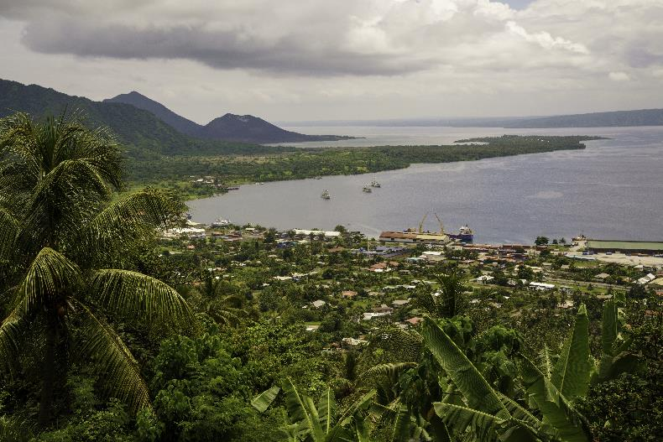

1. Asian Development Bank, *Meeting Asia’s Infrastructure Needs,* Manila, Philippines: ADB, 2017.
2. As noted in the Scope section, the Review team included AIFFP projects from 2022 to reflect that the bulk of the work for these projects was completed in the Review period of 2019–2021.
3. While the Review will examine whether the current operating model is fit-for-purpose, it is outside the Review’s scope to consider alternative operating models.
4. Some Pacific Island countries are eligible for AIFFP grants only, given their relatively high levels of debt.
5. As outlined in the Introduction, these are: Pacific countries have increased access to capital to support quality, resilient, and inclusive economic infrastructure; Australia delivers infrastructure financing that meets the development needs of Pacific countries; and Australia is a partner of choice for financing infrastructure in the Pacific.
6. We note that these calculations do not include resources across DFAT’s Pacific posts or EFA support and consultancy support staff. EFA shared that it has around 30 staff who spend a proportion of their time working on AIFFP matters, however, it was not within the Review's scope to quantify the EFA full-time equivalent staff numbers who work on AIFFP projects. The Review team also understands that DFAT has a large number of vacancies across the entire organisation, meaning that many areas – including the AIFFP – are unable to fill all vacant positions.
7. After this analysis was conducted, the AIFFP’s lending cap was increased to AUD3 billion. This is likely to make AIFFP’s staffing-to-funding ratio even smaller.
8. Where possible, the Review team sought to compare the AIFFP against financiers that share similar investment profiles. Although the AIFFP does not administer loans in the same manner as the ADB and WBG, it holds similar levels of responsibility for project origination and oversight. In light of this and significant data access limitations, we acknowledge that the ratios provided above can provide only a superficial indication of the relative staffing and resourcing levels between the institutions.
9. This DFAT taskforce was established in 2018 to support the construction of a high-speed undersea cable from Sydney to Port Moresby and Honiara.
10. As outlined in the Introduction, these strategic objectives are: Pacific countries have increased access to capital to support quality, resilient, and inclusive economic infrastructure; Australia delivers infrastructure financing that meets the development needs of Pacific countries; and Australia is a partner of choice for financing infrastructure in the Pacific.
11. This analysis and the analysis under Q1C are informed by the AIFFP investments listed in Table 1. Analysis also includes an additional AIFFP investment which remains commercial-in-confidence but was shared with the Review team for analysis purposes.
12. Please note that only one of the four AIFFP investments made in Papua New Guinea has been signed, while three remain designated as “pipeline”. The AIFFP’s one investment in the Solomon Islands has been signed and is designated “active”.
13. These were: Agriculture/Fisheries/Forestry; Construction/Industry/Mining; Disaster/Resilience; Energy/Utilities; Health; Other; Telecommunications/ICT; Aviation/Maritime/Transport; Urban Infrastructure; and Waster/Water/Sanitation/Sewerage. Classifications were modelled on the OECD Development Assistance Committee standard (also employed by the Lowy Pacific Aid Map and the International Aid Transparency Initiative). In certain cases, additional categories were added or combined for ease of analysis.
14. After this analysis was conducted, the AIFFP’s lending cap was increased to AUD3 billion.
15. Note that for Figures 4 and 5, 2022 data for the AIFFP is represented in light orange to demonstrate that it is incomplete, covering, as it does, commitments made to the end of February 2022 only.
16. This portfolio is constituted by five signed loans and three further loans currently designated as “pipeline”.
17. For instance, see: “Private Sector Development”, *jica.go.jp*, accessed 12.11.2021 <https://www.jica.go.jp/english/our_work/thematic_issues/private/activity>;

    “Inclusive Business Solution Program”, *koica.gov.kr*, accessed 12.11.2021 <http://www.koica.go.kr/koica_en/3447/subview.do>; “Private Sector Engagement Policy”, *usaid.gov*, accessed 12.11.2021 <https://www.usaid.gov/sites/default/files/documents/1865/usaid_psepolicy_final.pdf>; and Dornan M. & Brant P. *Chinese Assistance in the Pacific: Agency, Effectiveness and the Role of Pacific Island Governments*, Asia & the Pacific Policy Studies, Vol.1 Issue. 2, 2014